Indiana Pacers

May 14, 2021

May 15, 2021

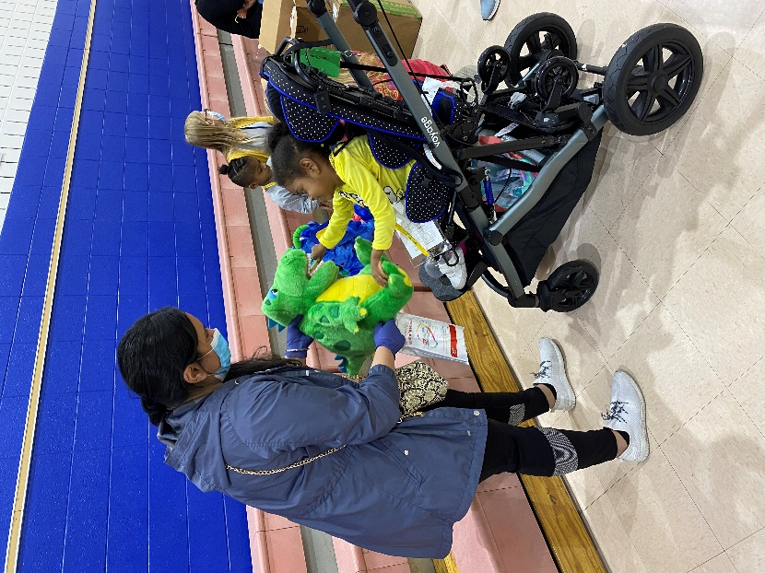

Ignite Achievement Academy

Participated in Event: 141

Total Care & Education Provided $23,089

Average Dental Care & Oral Health Education per patient visiting clinic $194

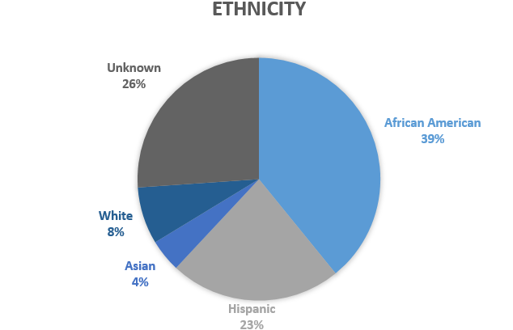
PATIENT DATA
Sealants Present

34%

16%

Treated Decay

Untreated Decay

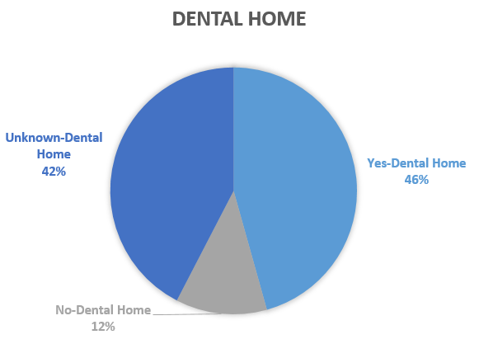
Screened | 119 | $9,639
Fluoride Varnish | 85 | $3,910
Silver Diamine Fluoride | 71 | $3,195
Oral Health Education | 141 | $6,345
Total Dollar Amount |  | $23,089

