Carolina Panthers

March 11, 2022

Lead Dentist: Dr. Matt Lineberger


Nations Ford & Albemarle Elementary Schools

Participated in Event: 306

Total Preventative Care & Education Provided $107,777

Average Dental Care & Oral Health Education per patient visiting clinic $352.21

PATIENT DATA
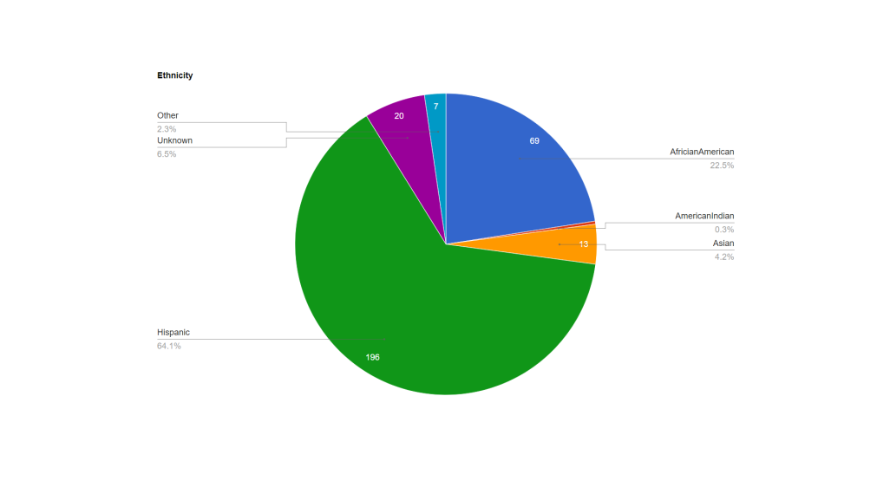
Sealants Present

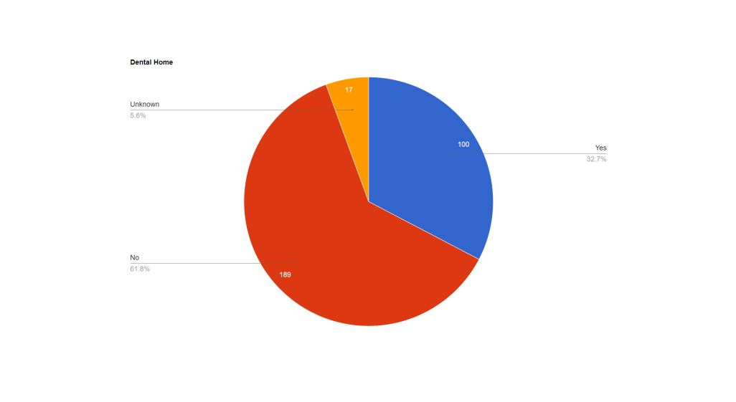

Nations Ford Elementary School

Cleanings & Fluoride Varnish | 100
X-Rays | 44
Screening/Varnish | 46
Silver Diamine Fluoride | 161
Extractions | 15
Pulpotomy | 0
Fillings | 1
Crowns | 0
Oral Health Education | 146

Albemarle Elementary School

Cleanings & Fluoride Varnish | 161
X-Rays | 94 BWS; 2 PA’s
Silver Diamine Fluoride | 89
Extractions | 54
Pulpotomy | 2
Fillings | 21
Crowns | 3
Oral Health Education | 161
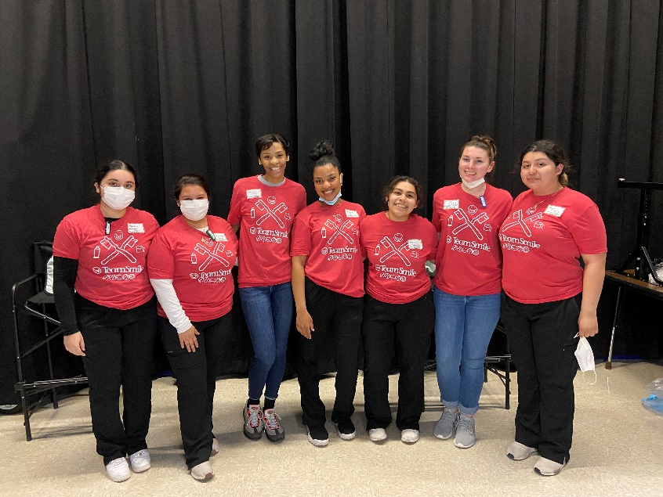
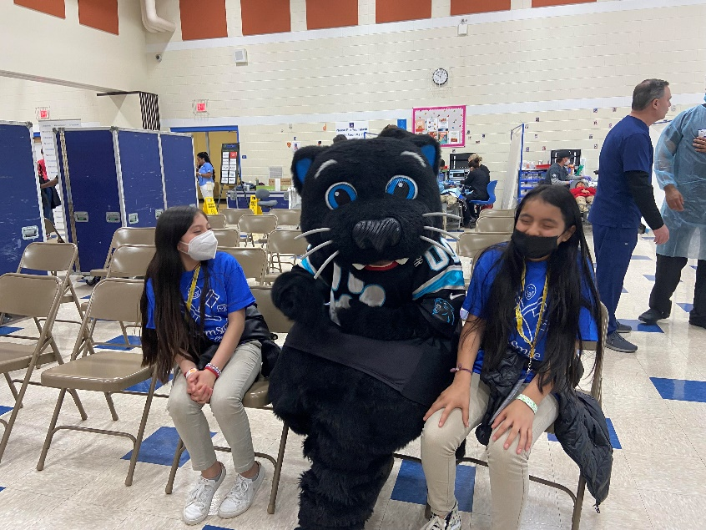

Sponsored By:

