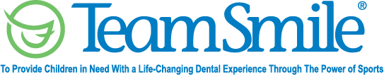
Chicago Bears
August 6, 2022
Location of Dental Clinic: Halas Hall

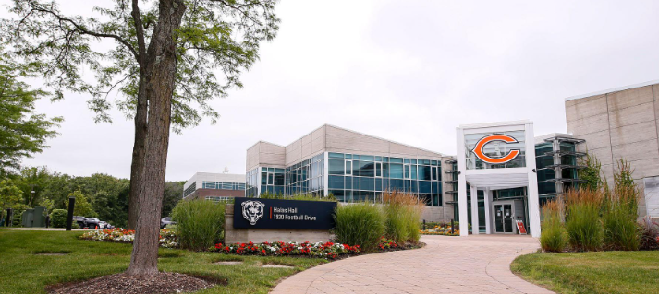
Health Fair
45 Children Served
45 Children Educated

Total Preventative Care & Education Provided $21,592
Average Dental Care & Oral Health Education per patient visiting Program $434.82

Sponsored by: Dr. Nicholas Chionis D.M.D and Bears Care
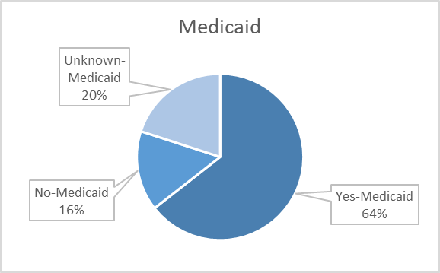
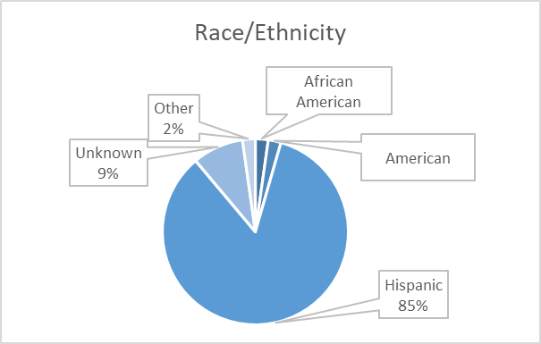
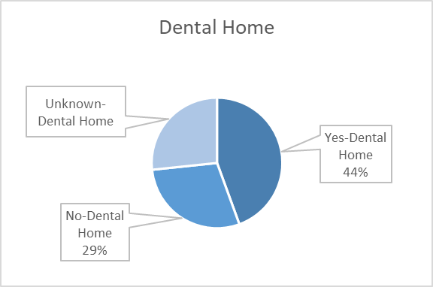
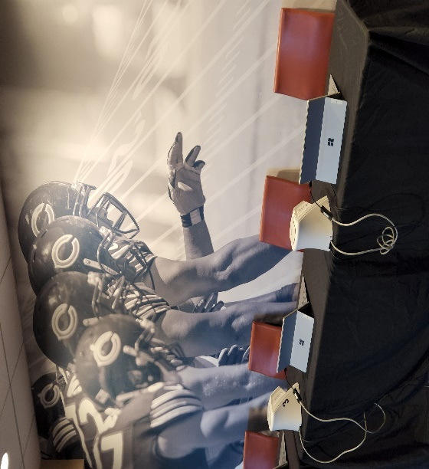
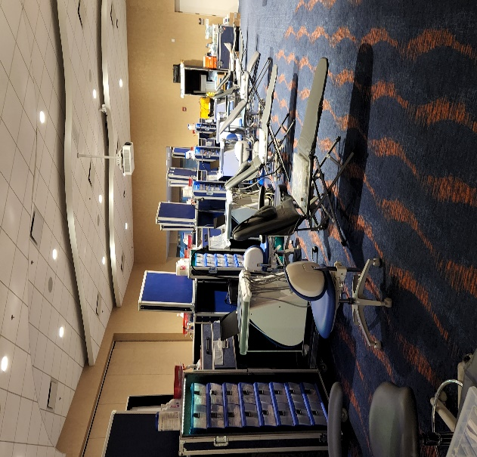
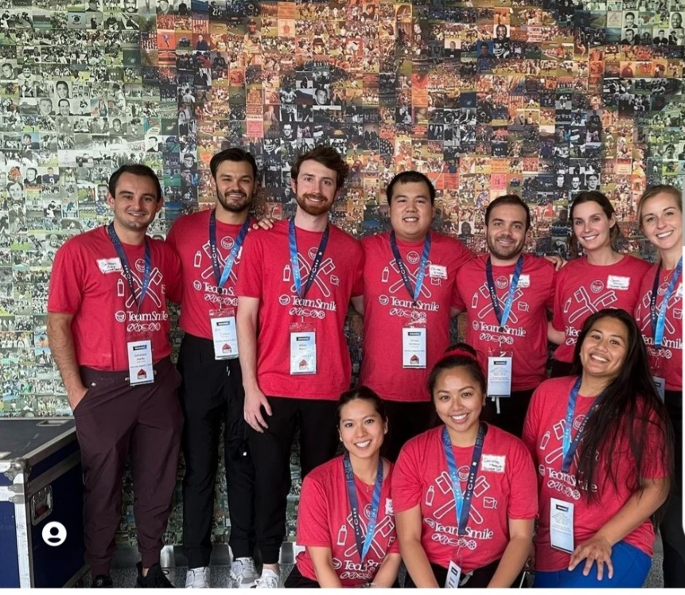
Volunteers
Thank you to our volunteers for your time and talents.
Dentists | 14 | 3
Hygienists | 15 | 11
Dental Assistants | 9 | 4
Dental School Students | 19 | 13
General Volunteers | 49 | 40
Total Volunteers | 106 | 71

Signed up Attended
67% Of the volunteers that signed up through our website attended the event.
Screenings | 45
X-Rays | 24
Prophy Cleanings | 31
Fluoride Varnish | 27
Sealants | 72
Fillings | 17
Extractions | 8
Pulpotomies | 2
Silver diamine fluoride | 9
Oral Health Education | 45

Services

Total Value: $21,592
Dental Services: $19,597
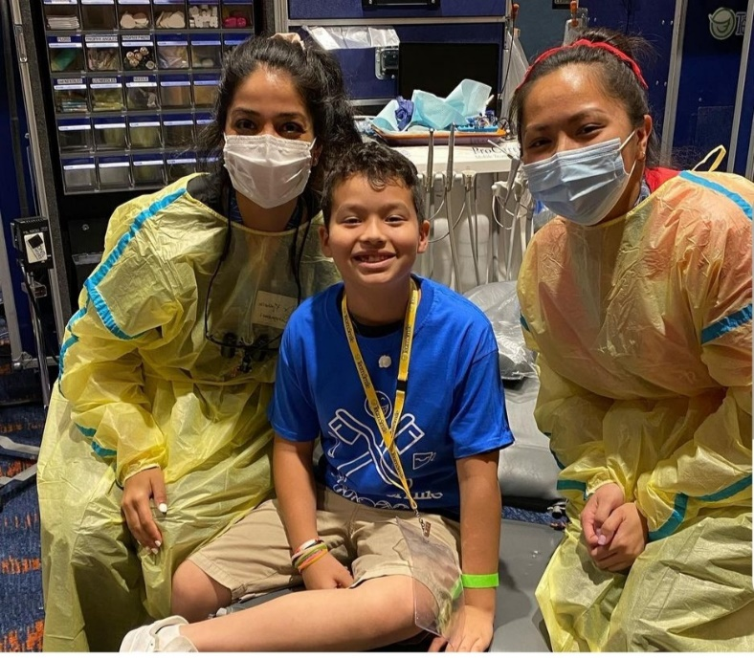
Education: $2,025

