
Kansas City Chiefs
August 27, 2022
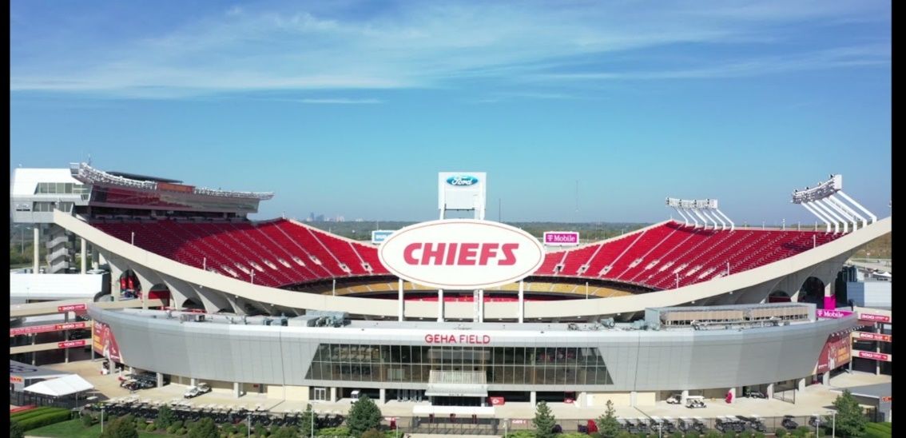
Location of Dental Clinic : GEHA Field at Arrowhead Stadium
418 children served
442 children educated

Total Preventative Care & Education Provided $154,405
Average Dental Care & Oral Health Education per patient visiting Program $349.33

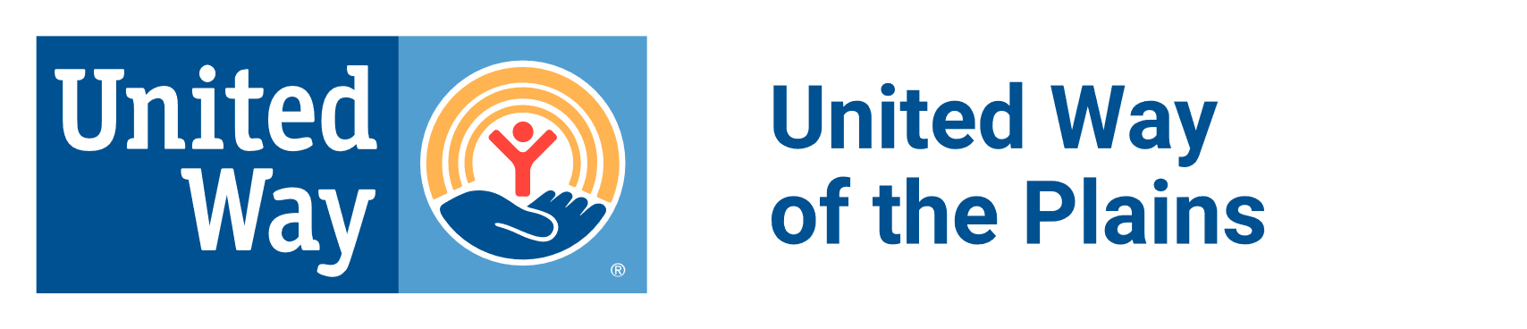
Sponsored by:
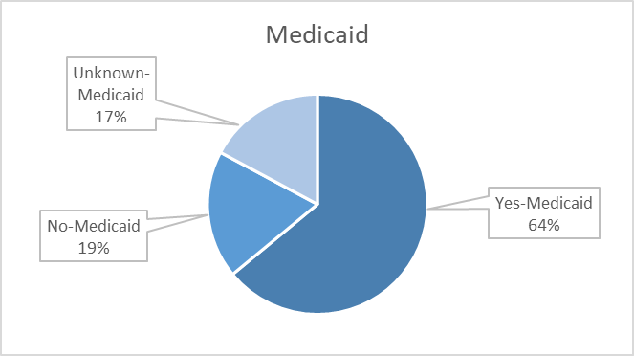

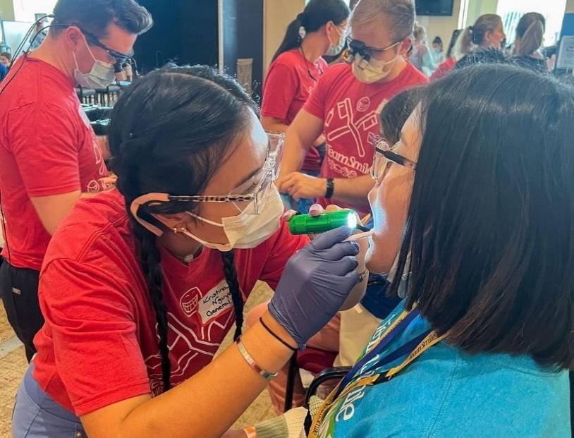
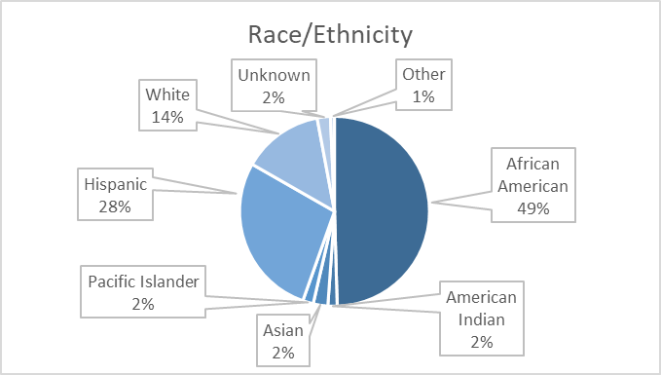
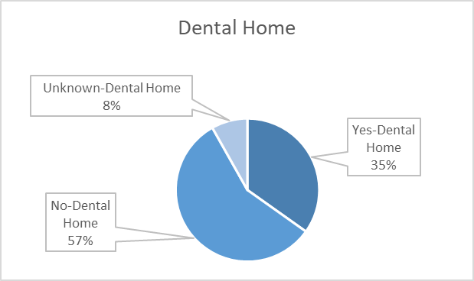

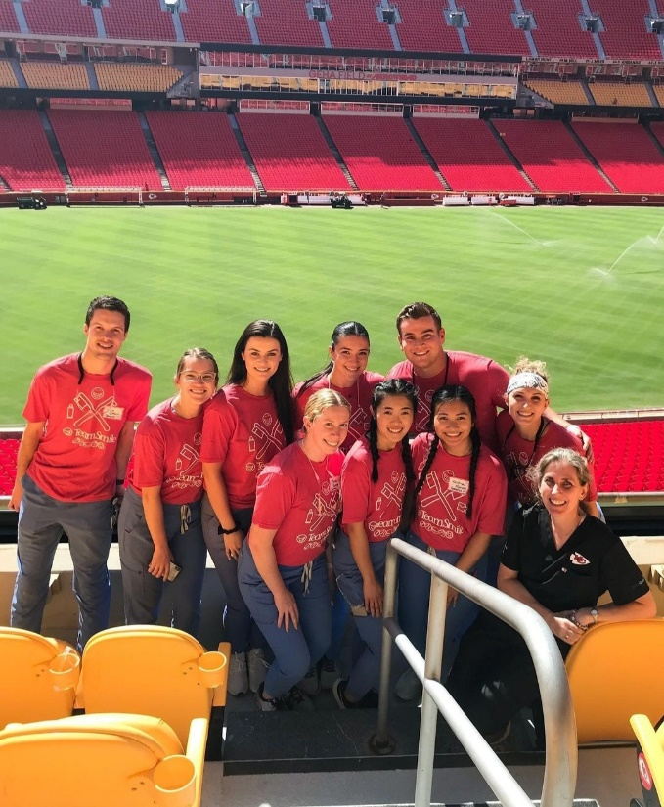
Volunteers
Thank you to our volunteers for your time and talents.
Dentists | 23 | 18
Hygienists | 30 | 21
Dental Assistants | 36 | 26
Dental School Students | 73 | 57
General Volunteers | 90 | 65
Total Volunteers | 252 | 187
Signed up Attended
74% Of the volunteers that signed up through our website attended the event.

Screenings | 418
X-Rays | 346
Prophy Cleanings | 314
Fluoride Varnish | 291
Sealants | 259
Fillings | 50
Extractions | 67
Crowns | 4
Pulpotomies | 3
Silver diamine fluoride | 106
Root Canals | 1
Oral Health Education | 442
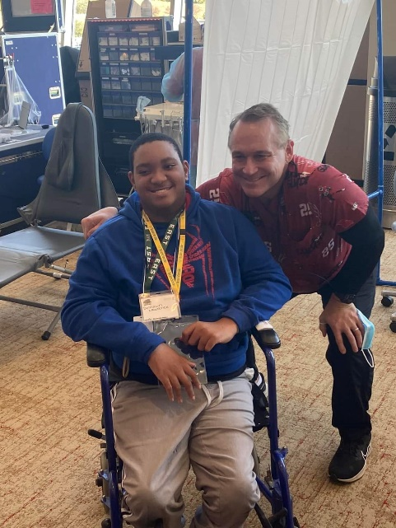
Services
Total Value: $154,405
Dental Services: $134,515
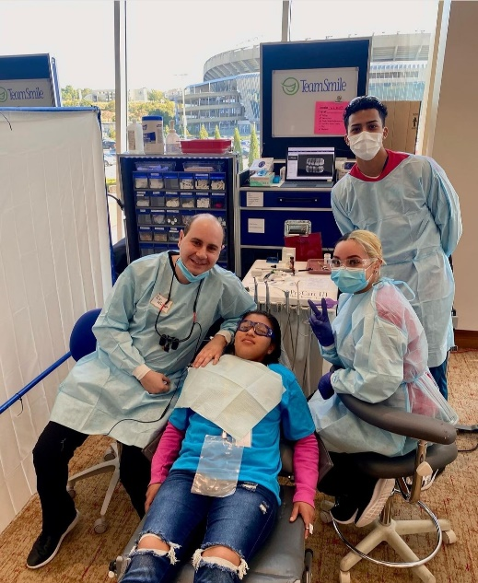
Education: $19,890

