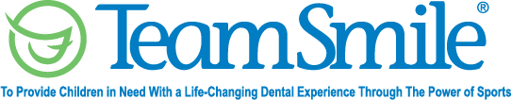
Cleveland Program
June 30, 2023
Location of Dental Clinic: FirstEnergy Stadium

216 Children Served
216 Children Educated
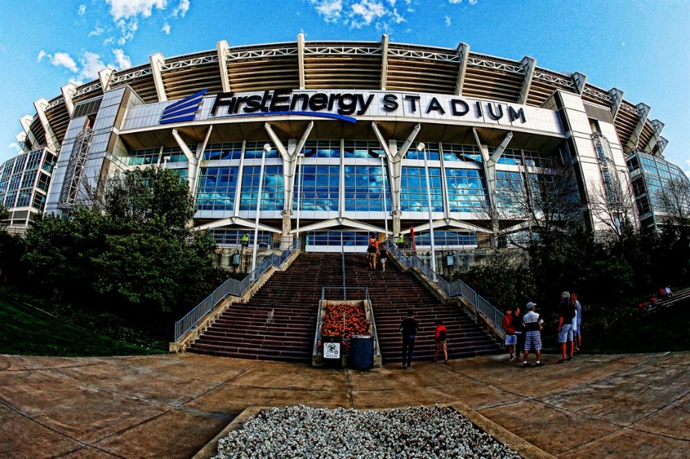

Total Preventative Care & Education Provided $94,943
Average Dental Care & Oral Health Education per patient visiting Program $439.55


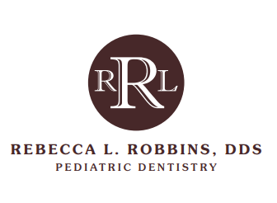
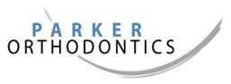
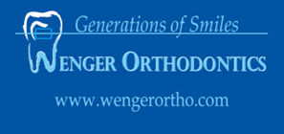
Sponsored by:
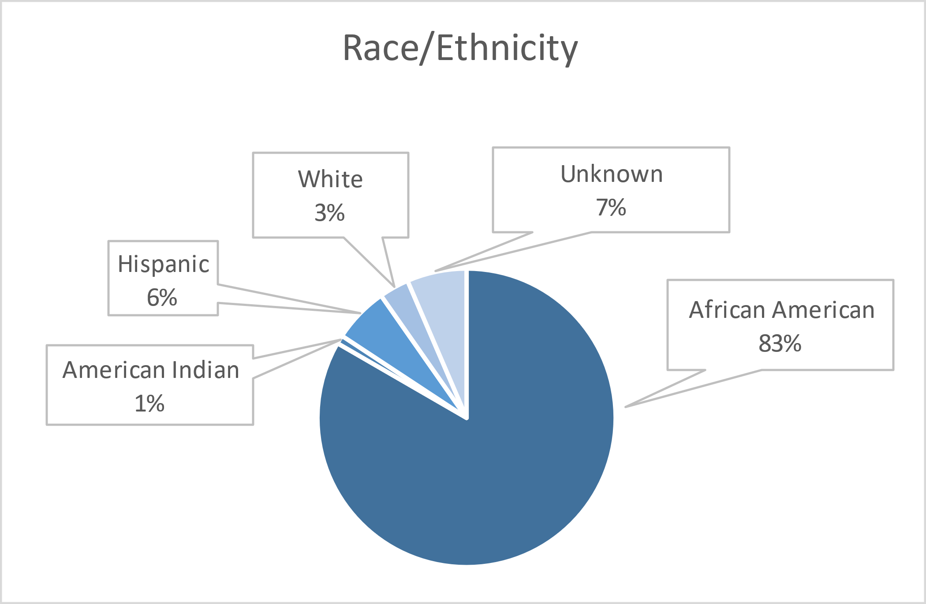
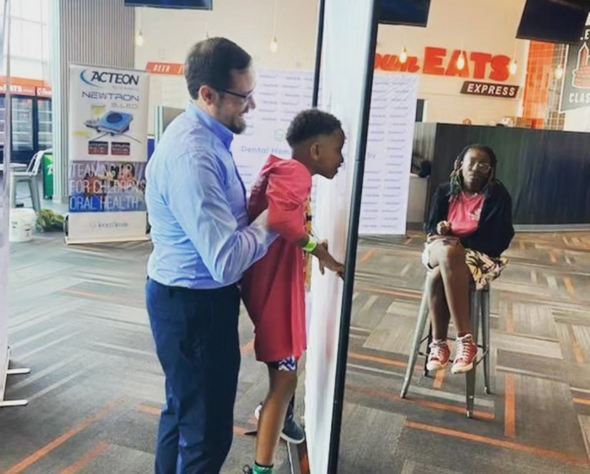
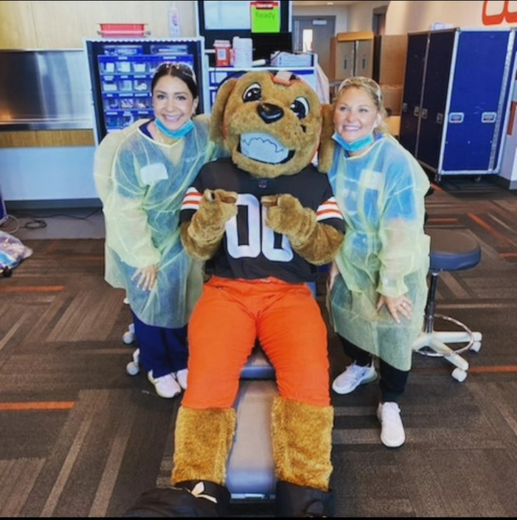
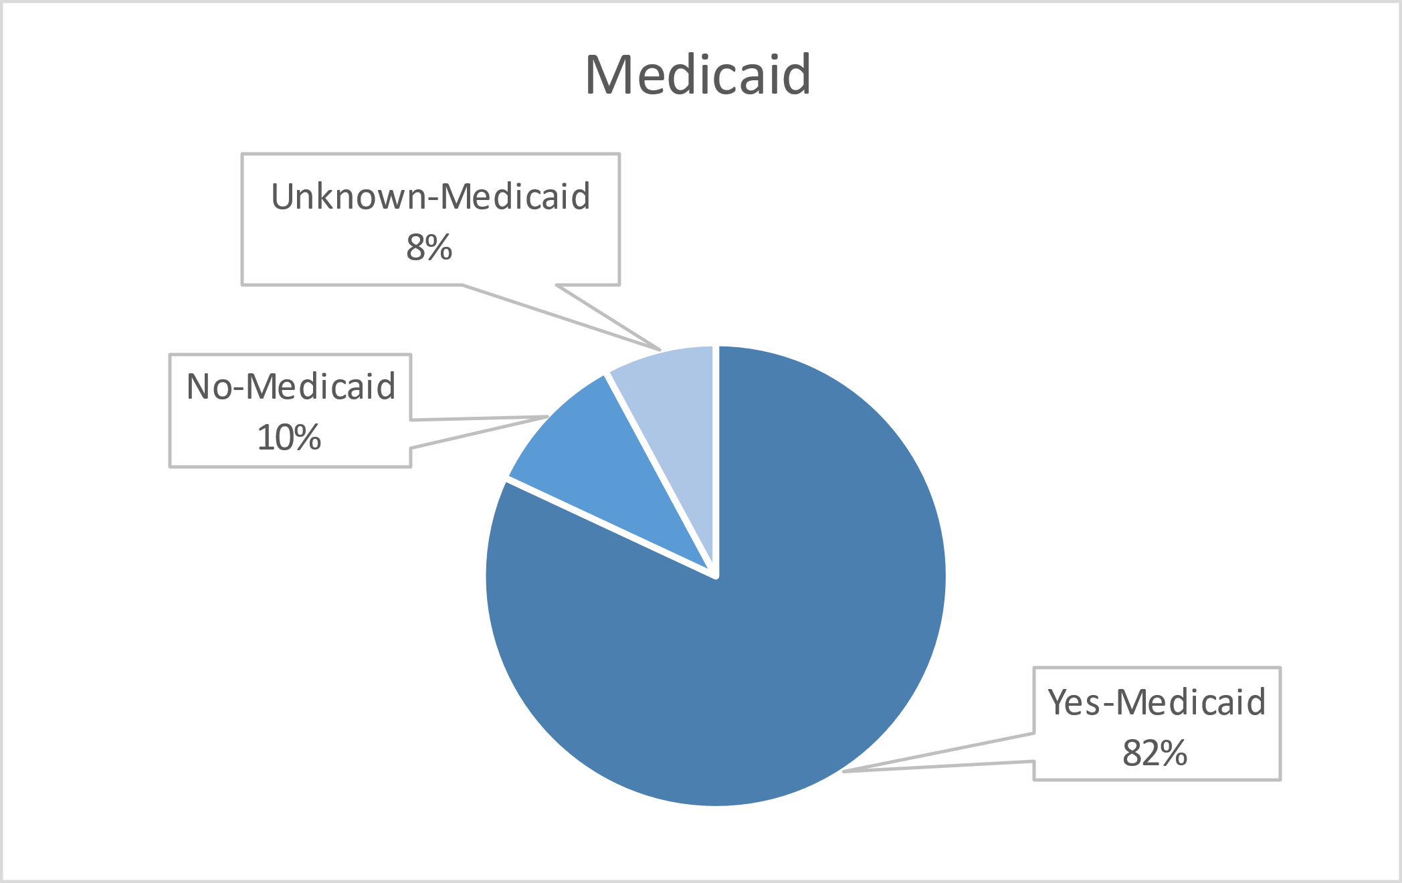
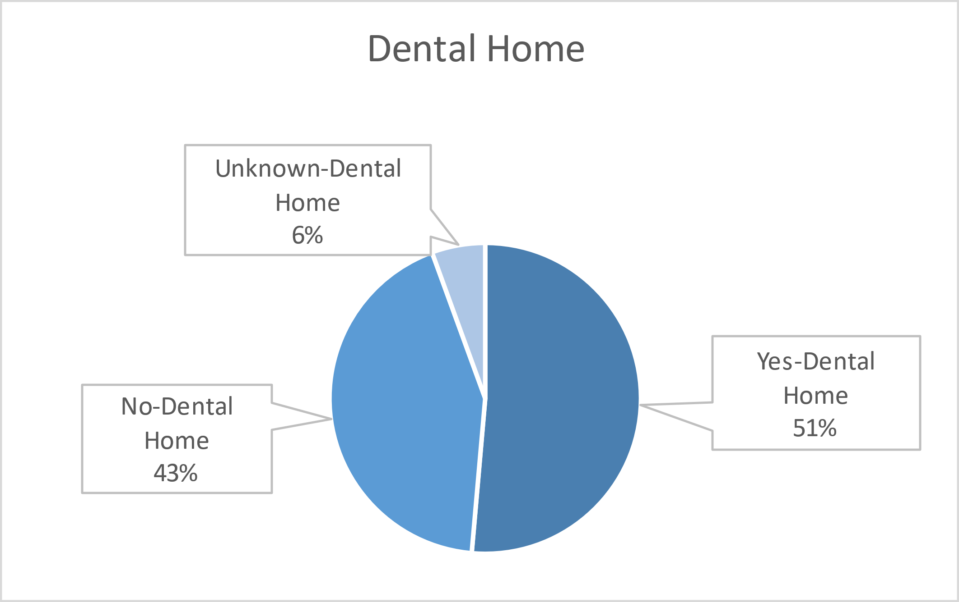
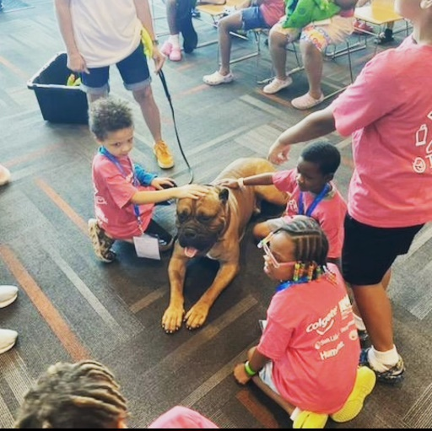
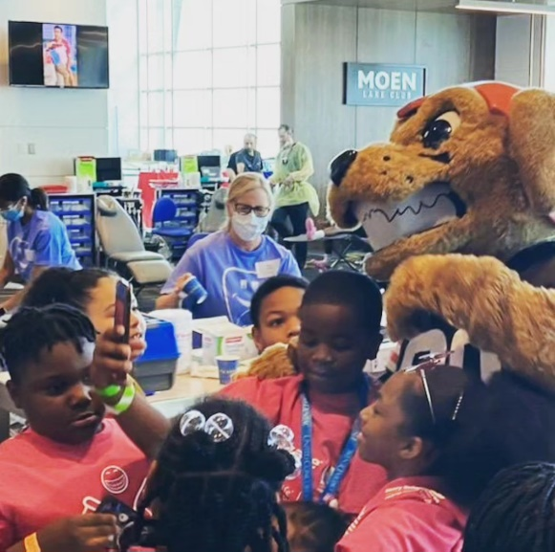
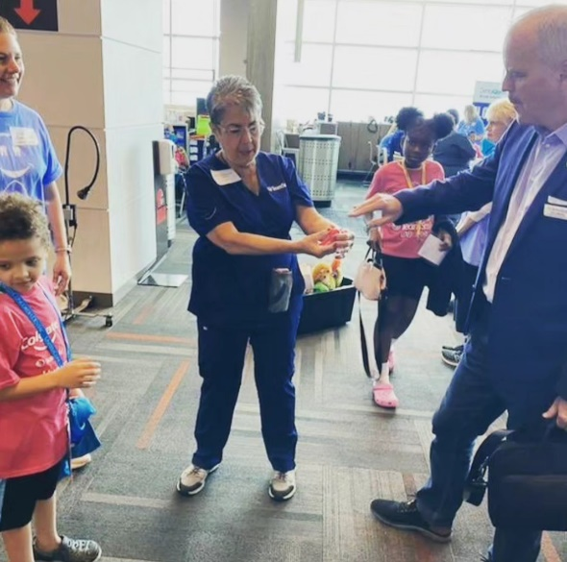
Volunteers
Thank you to our volunteers for your time and talents.
Dentists | 22 | 20
Hygienists | 13 | 9
Dental Assistants | 19 | 14
General Volunteers | 61 | 35
Total Volunteers | 115 | 78

Signed up Attended
68% Of the volunteers that signed up through our website attended the event.

Services

Screenings | 216
X-Rays | 186
Prophy Cleanings | 172
Fluoride Varnish | 121
Sealants | 495
Fillings | 29
Extractions | 8
Silver diamine fluoride | 34
Crowns | 1
Oral Health Education | 216
Total Value: $94,943
Dental Services: $85,223
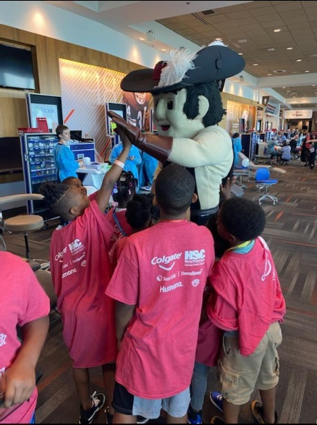
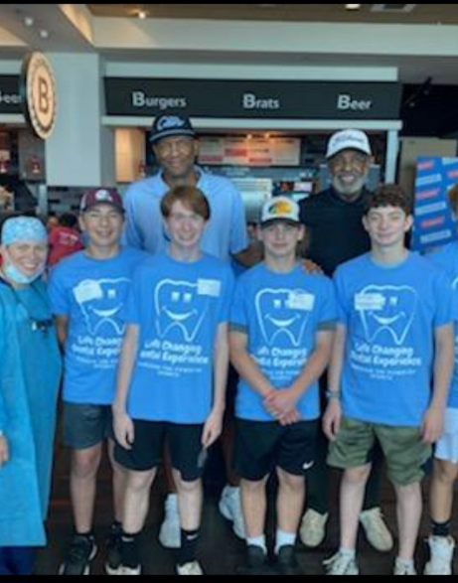
Education: $9,720

