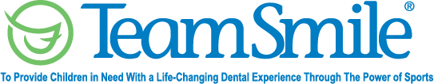
El Paso Chihuahuas
September 12, 2022
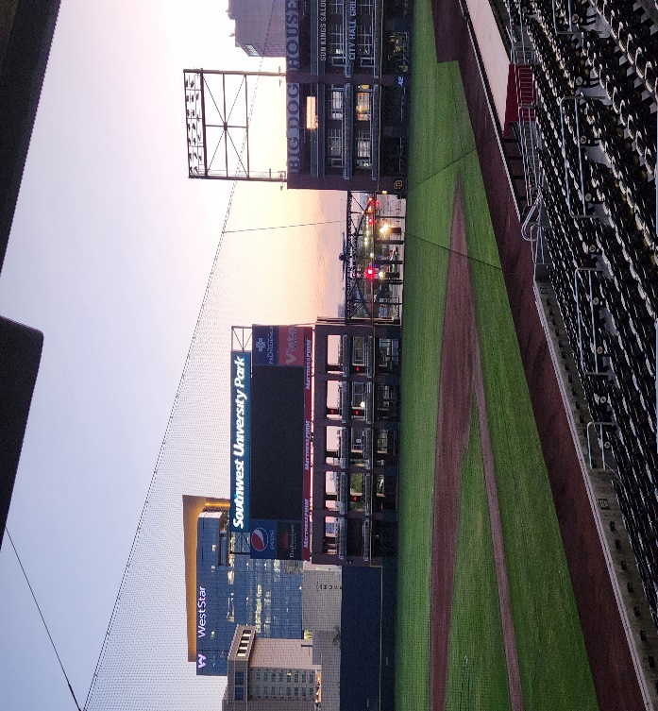
Location of Dental Clinic: Southwest University Park
Fabens Independent School District
237 Children Served
244 Children Educated
Total Preventative Care & Education Provided $97,978
Average Dental Care & Oral Health Education per patient visiting Program $367.08

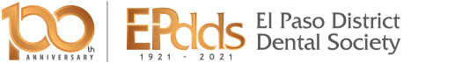

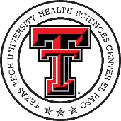
Sponsored by:
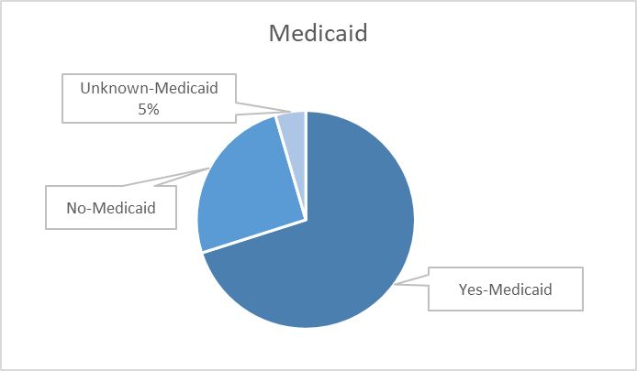
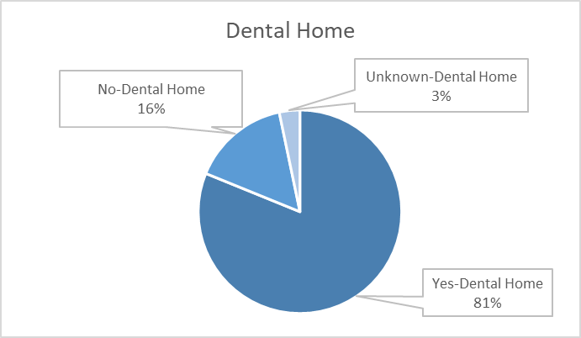
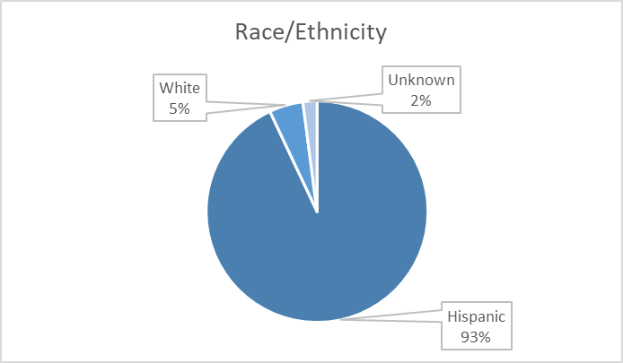
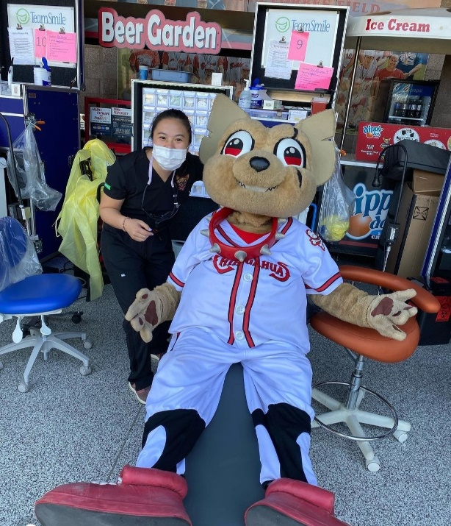
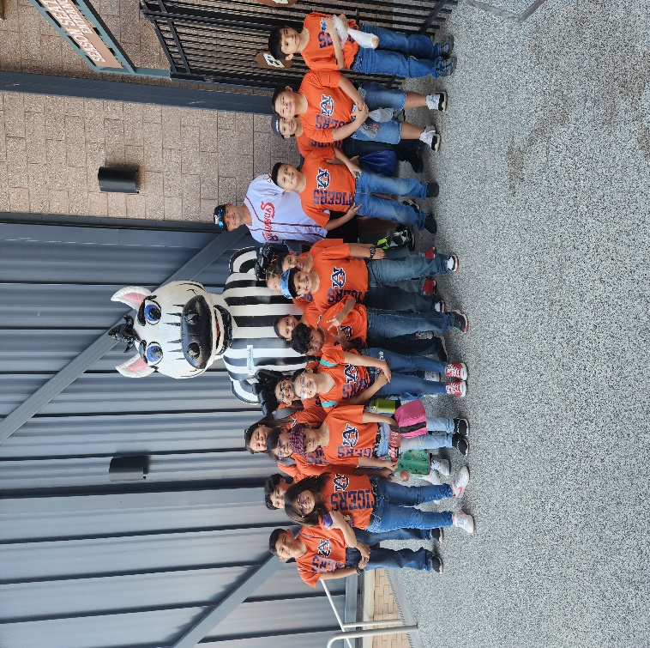

Volunteers
Thank you to our volunteers for your time and talents.
Dentists | 25 | 18
Hygienists | 18 | 16
Dental Assistants | 40 | 23
Dental School Students | 41 | 30
General Volunteers | 131 | 102
Total Volunteers | 255 | 189

Signed up Attended
74% Of the volunteers that signed up through our website attended the event.

Services

Screenings | 237
X-Rays | 62
Prophy Cleanings | 211
Fluoride Varnish | 202
Sealants | 354
Fillings | 53
Extractions | 14
Silver diamine fluoride | 10
Crowns | 6
Pulpotomies | 2
Oral Health Education | 244
Total Value: $97,978
Dental Services: $86,998
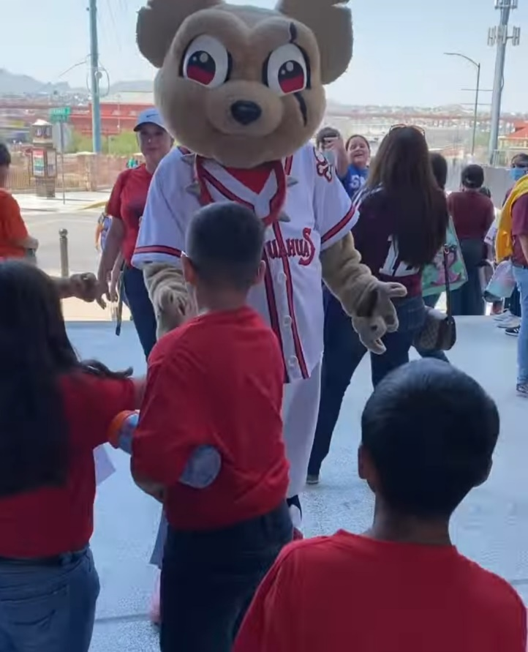
Education: $10,980

