
Memphis Grizzlies
September 30, 2022
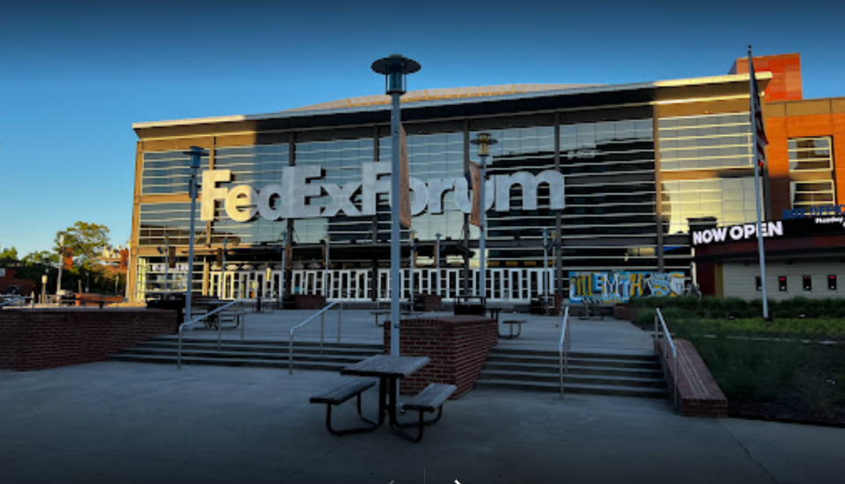
Location of Dental Clinic : FedExForum
150 children served
150 children educated

Total Preventative Care & Education Provided $33,786
Average dental care provided for each patient in the dental clinic $180.24


Sponsored by:
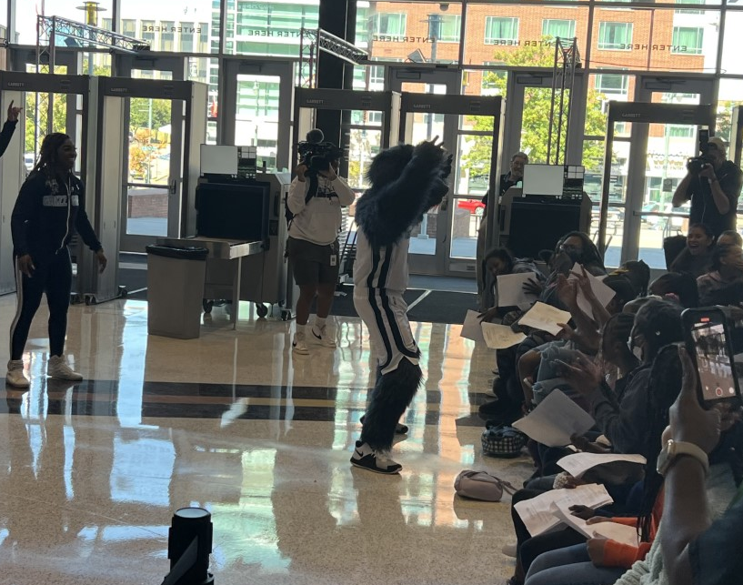
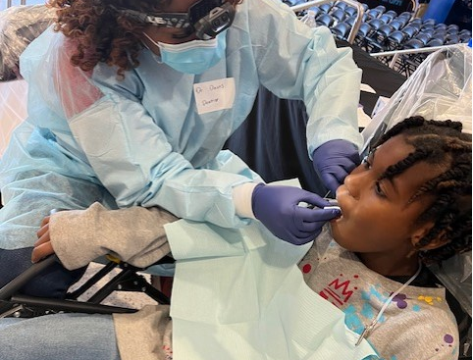
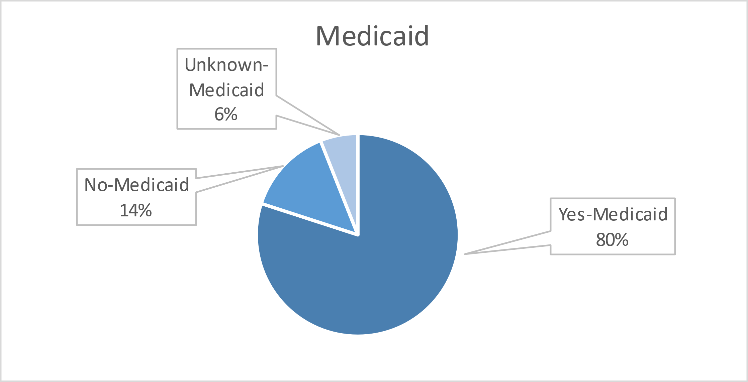
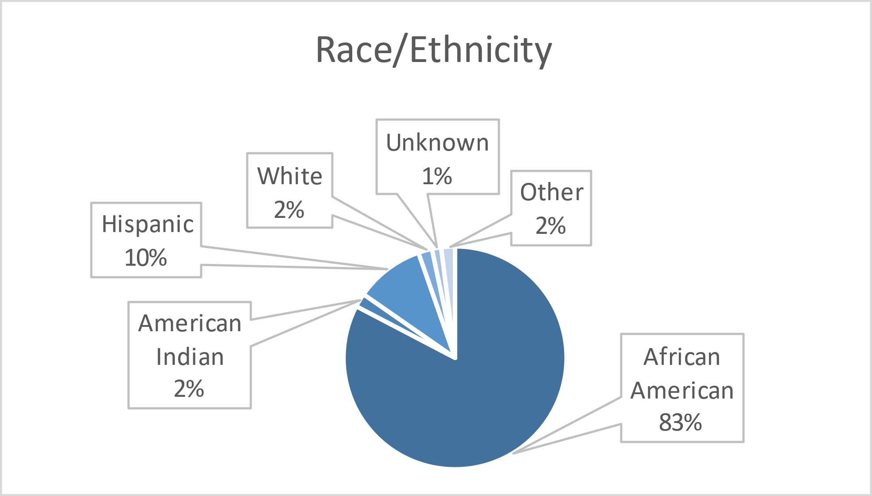
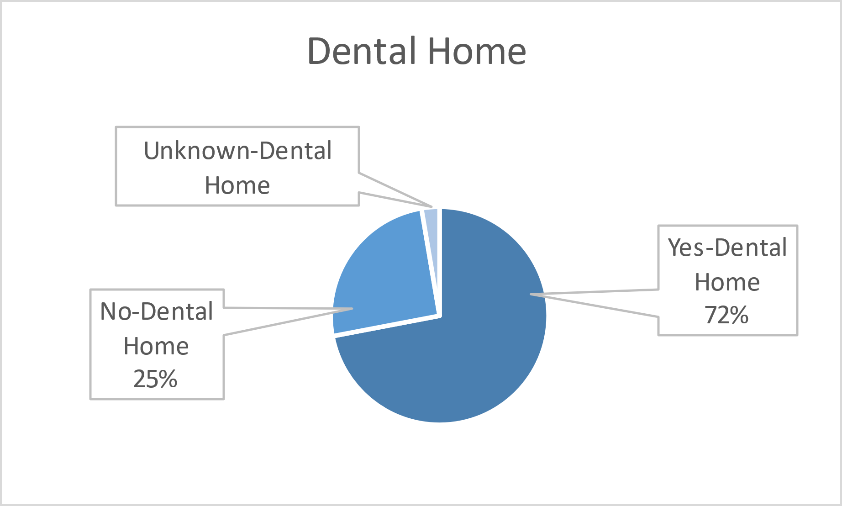

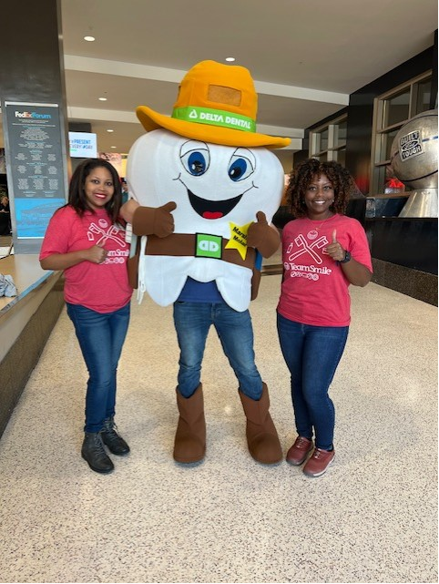
Volunteers
Thank you to our volunteers for your time and talents.
Dentists | 4 | 2
Hygienists | 6 | 6
Dental Assistants | 4 | 2
Dental School Students | 20 | 20
General Volunteers | 4 | 3
Total Volunteers | 38 | 33
Signed up Attended
87% Of the volunteers that signed up through our website attended the event.

Screenings | 150
Prophy Cleanings | 61
Fluoride Varnish | 142
Silver diamine fluoride | 85
Oral Health Education | 150
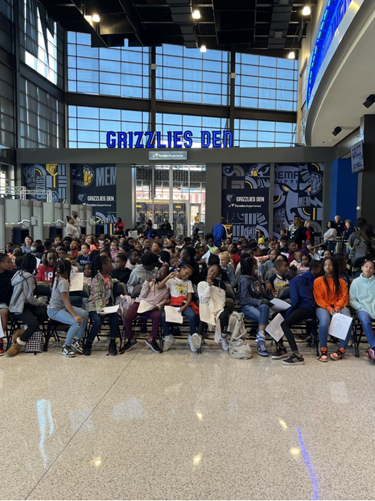
Services
Total Value: $33,786
Dental Services: $27,036
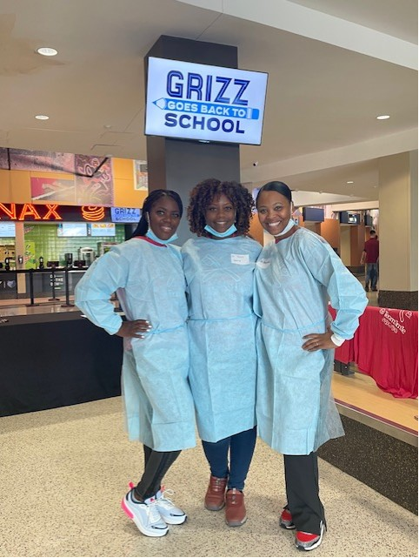
Education: $6,750

