
Milwaukee Brewers
June 27, 2023
Location of Dental Clinic: American Family Field
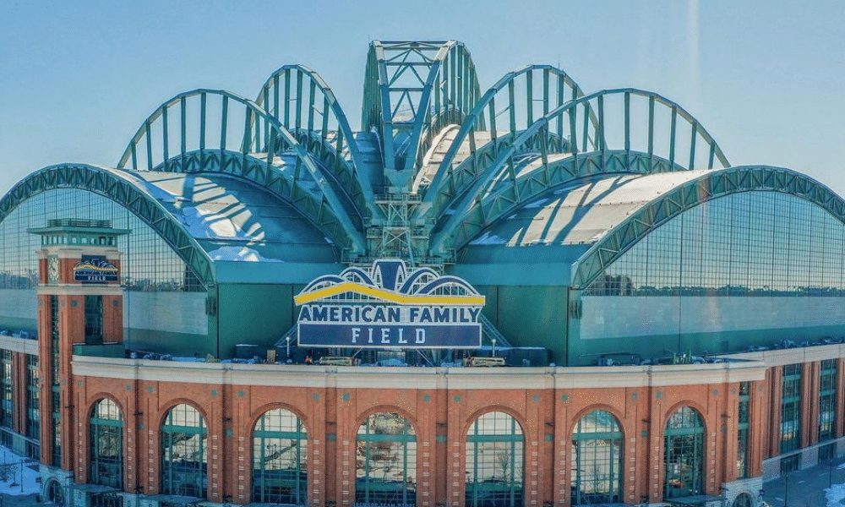

169 Children Served
169 Children Educated

Total Preventative Care & Education Provided $56,483
Average Dental Care & Oral Health Education per patient visiting Program $334.21



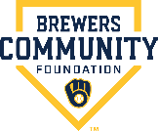
Sponsored by:
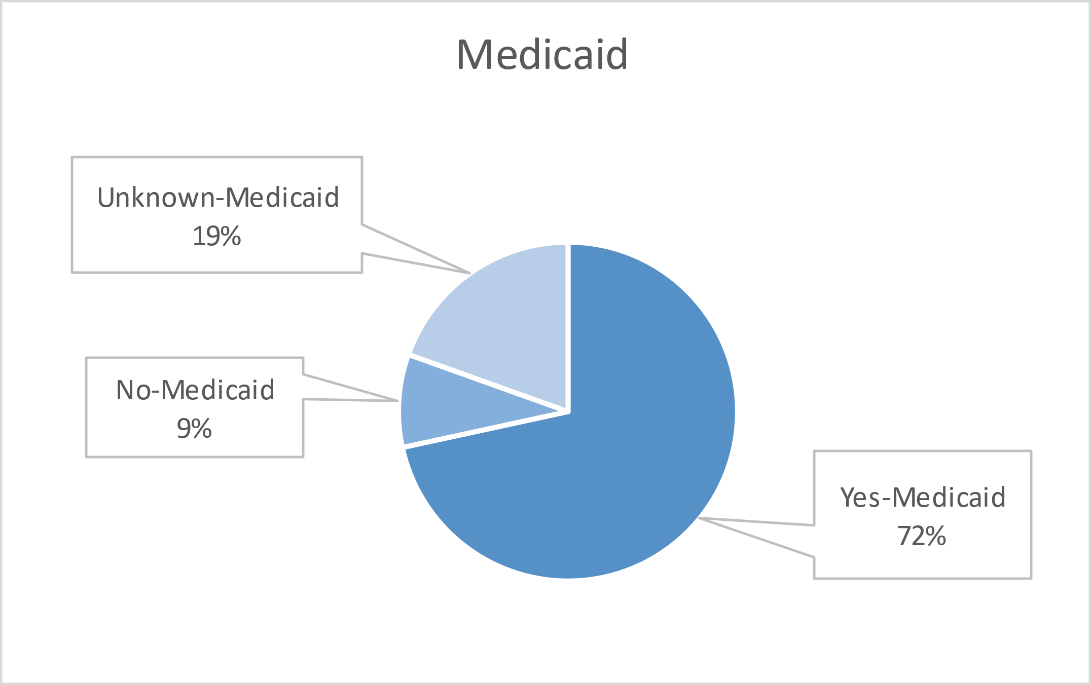
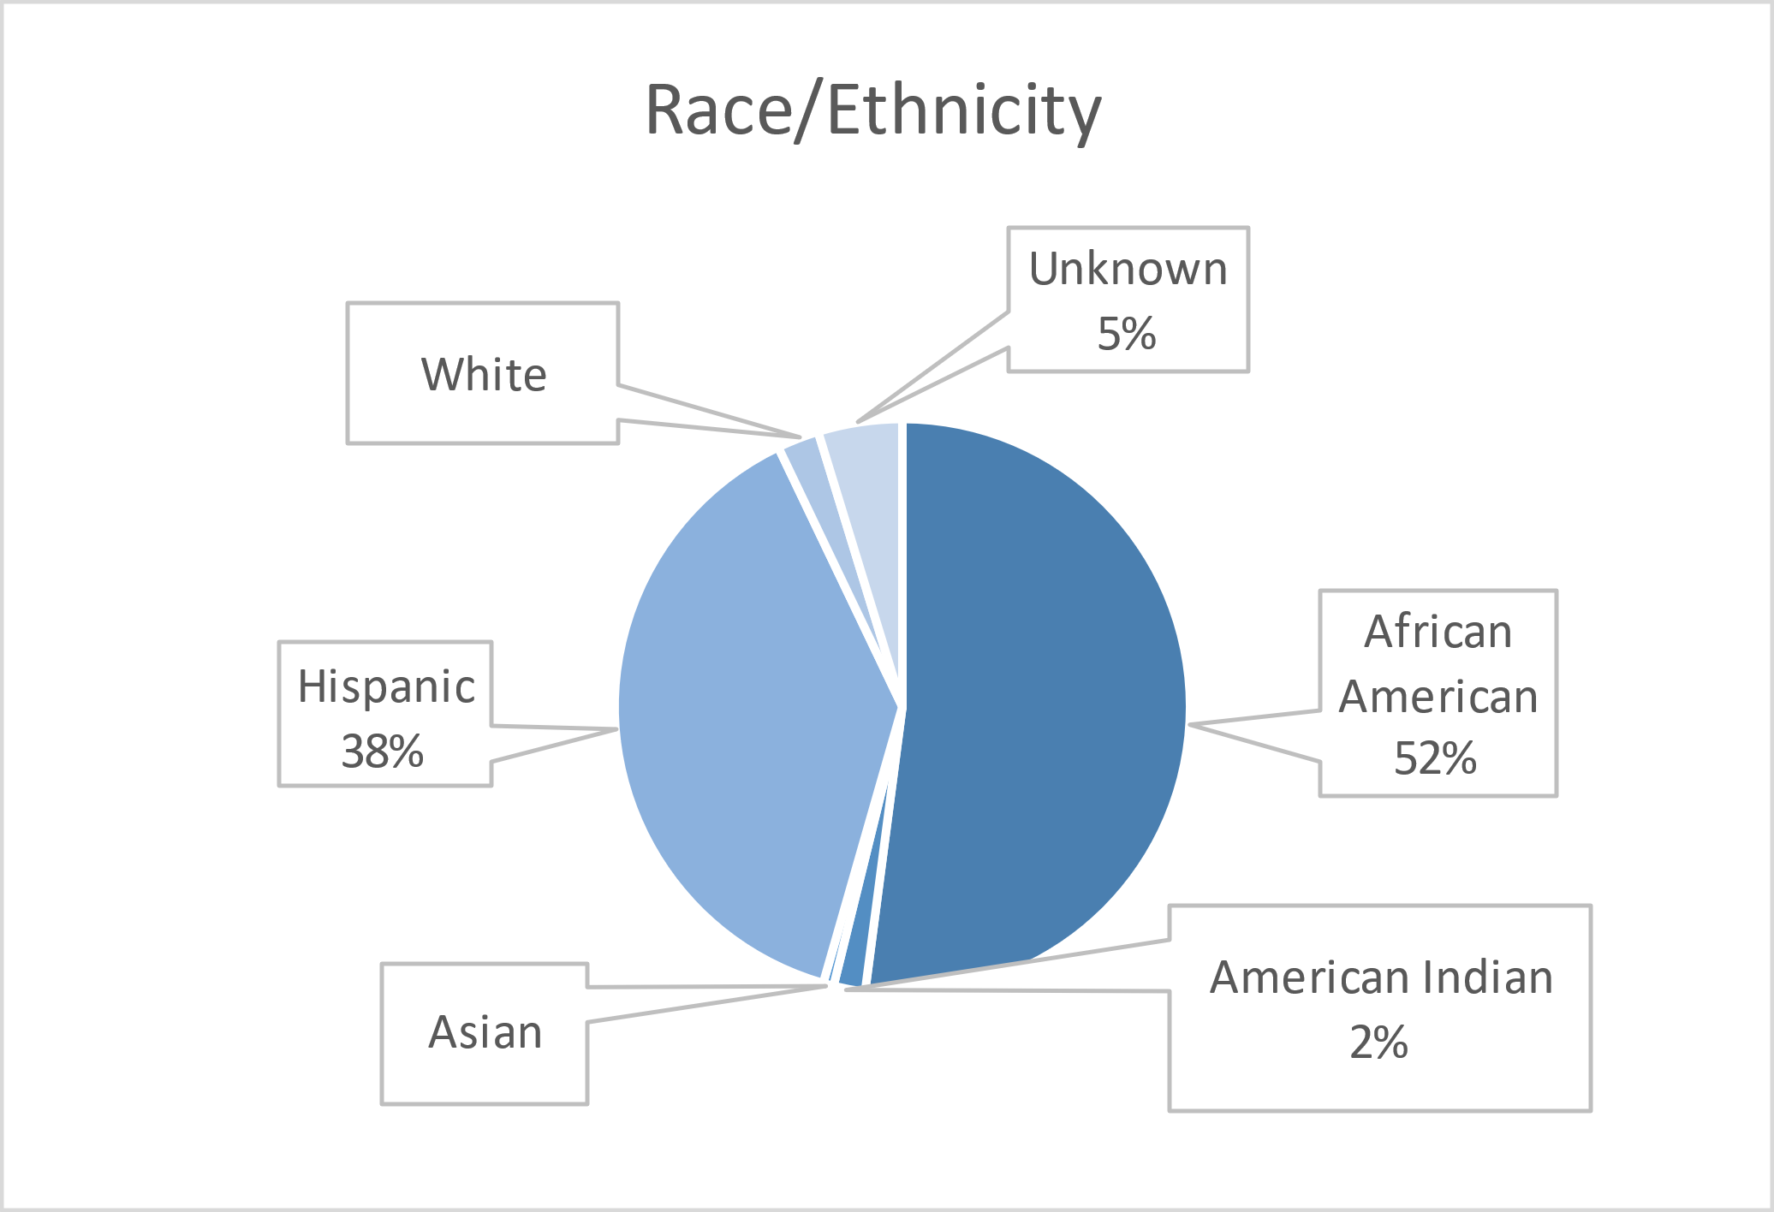
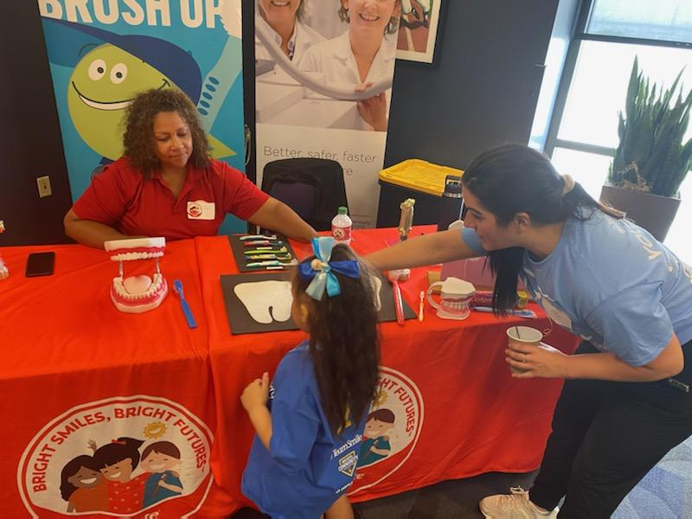
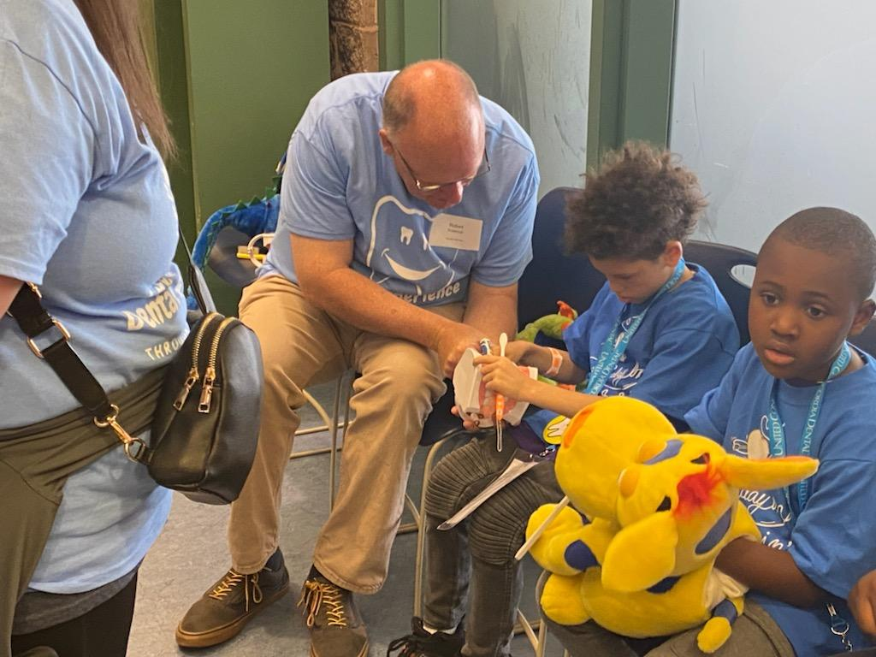
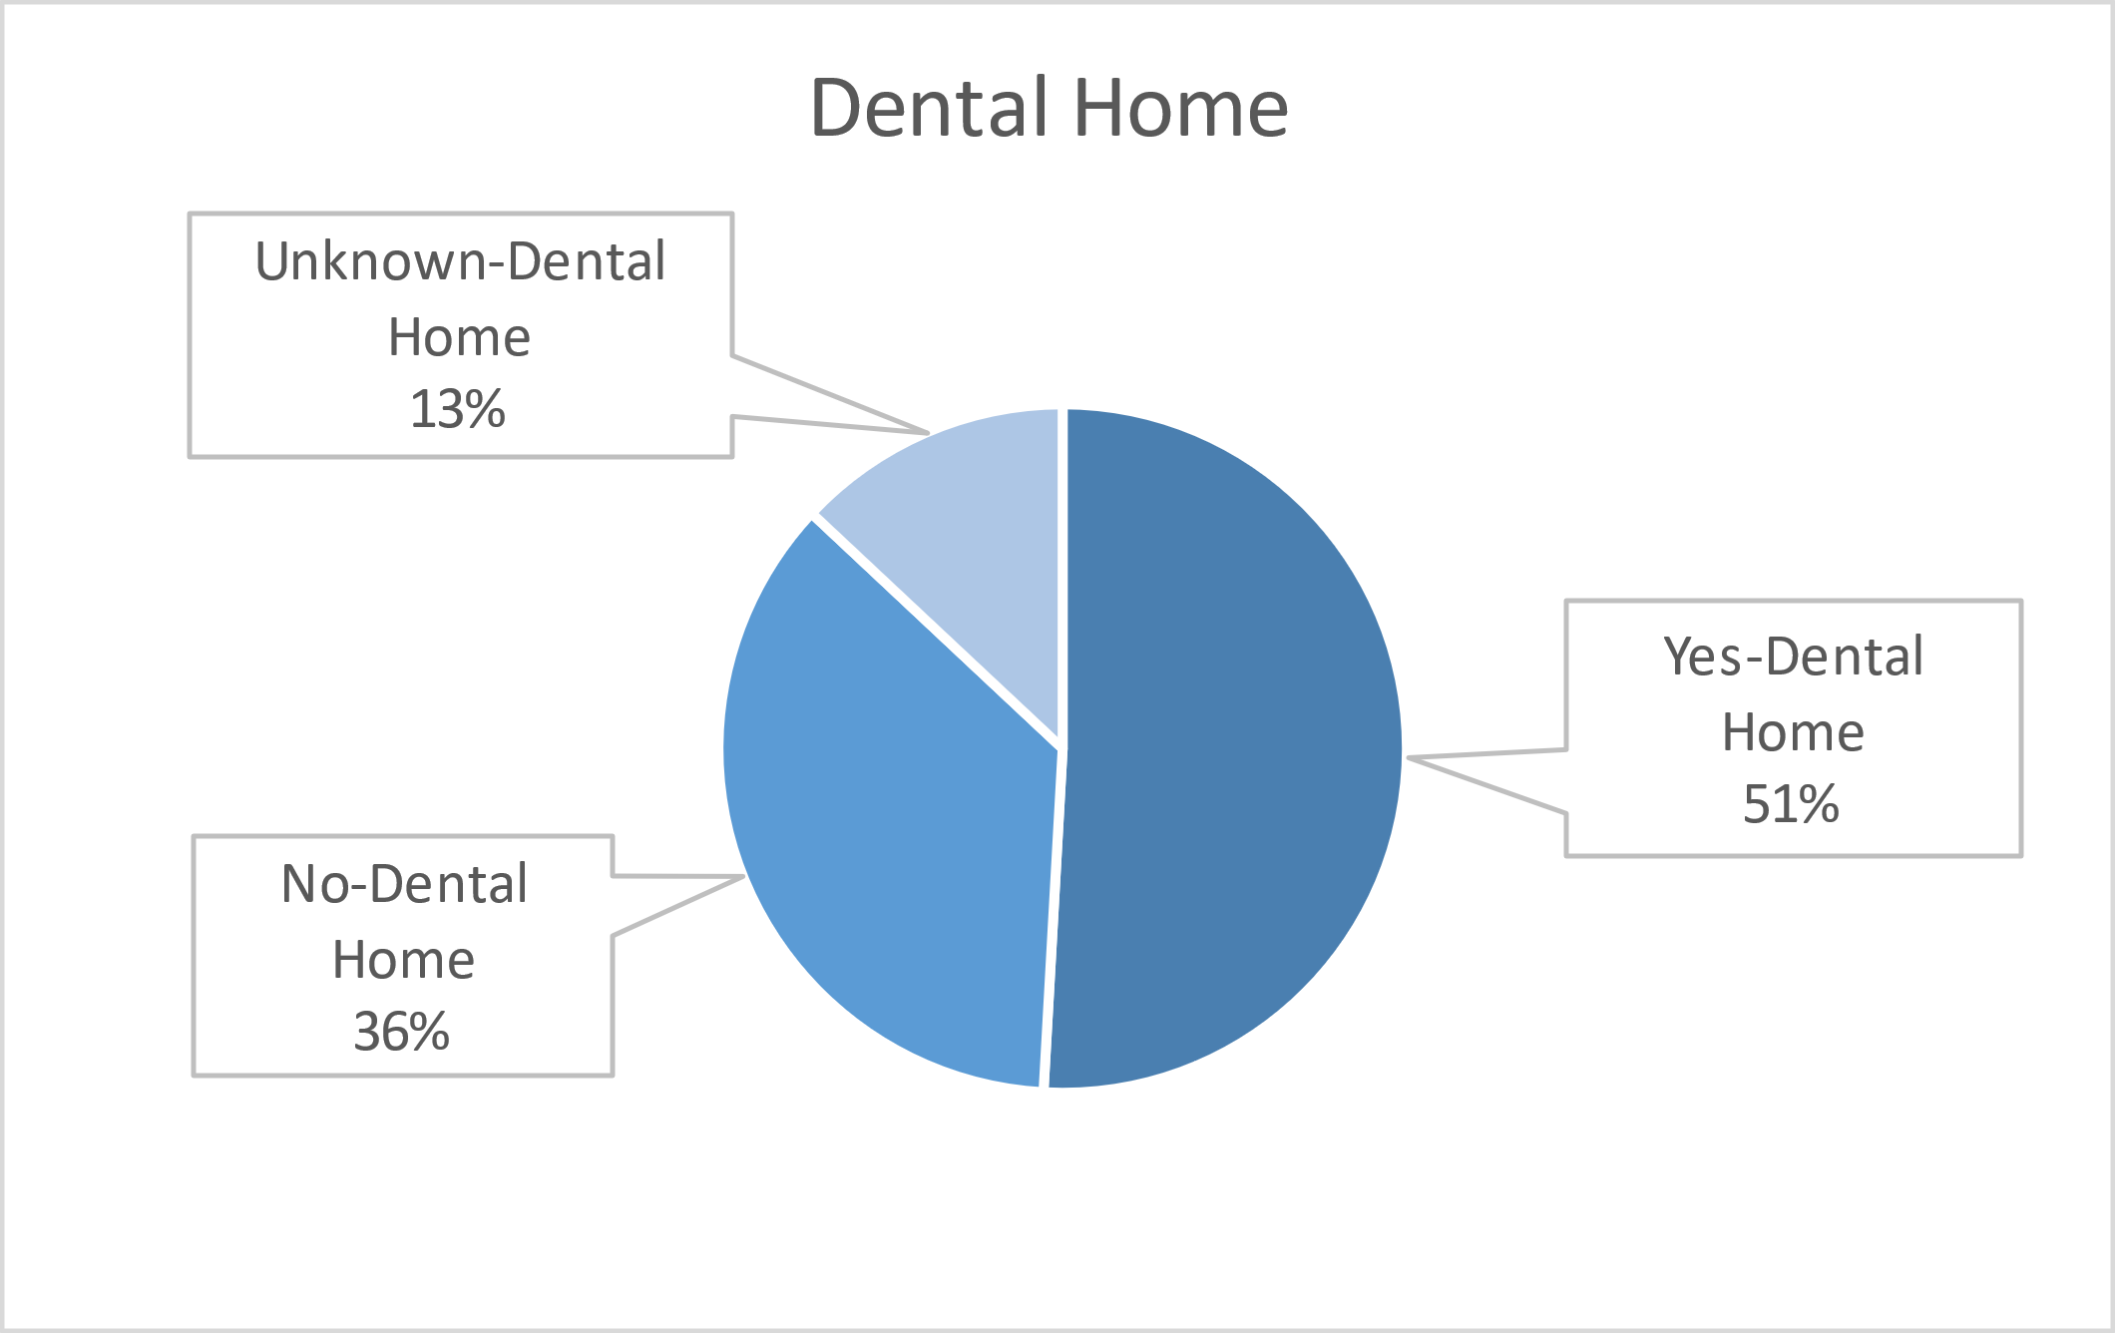
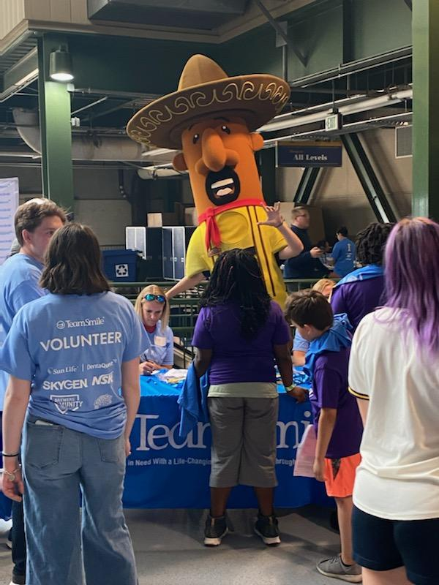
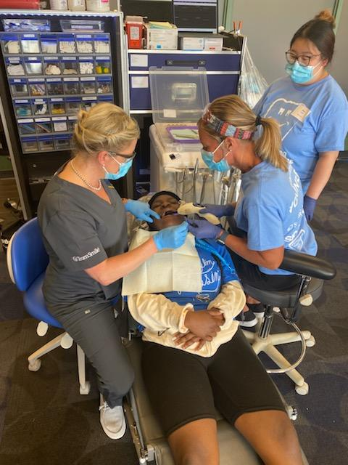
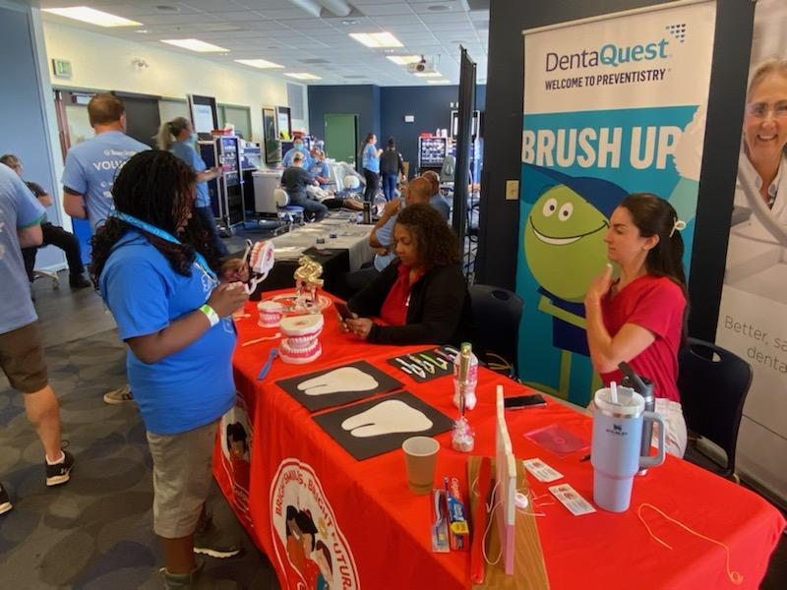
Volunteers
Thank you to our volunteers for your time and talents.
Dentists | 9 | 8
Hygienists | 9 | 5
Dental Assistants | 23 | 15
Dental School Students | 12 | 11
General Volunteers | 103 | 76
Total Volunteers | 156 | 113

Signed up Attended
73% Of the volunteers that signed up through our website attended the event.

Services

Screenings | 169
X-Rays | 56
Prophy Cleanings | 129
Fluoride Varnish | 124
Sealants | 140
Fillings | 20
Extractions | 9
Silver diamine fluoride | 37
Crowns | 2
Pulpotomy | 1
Oral Health Education | 169
Total Value: $56,483
Dental Services: $48,878
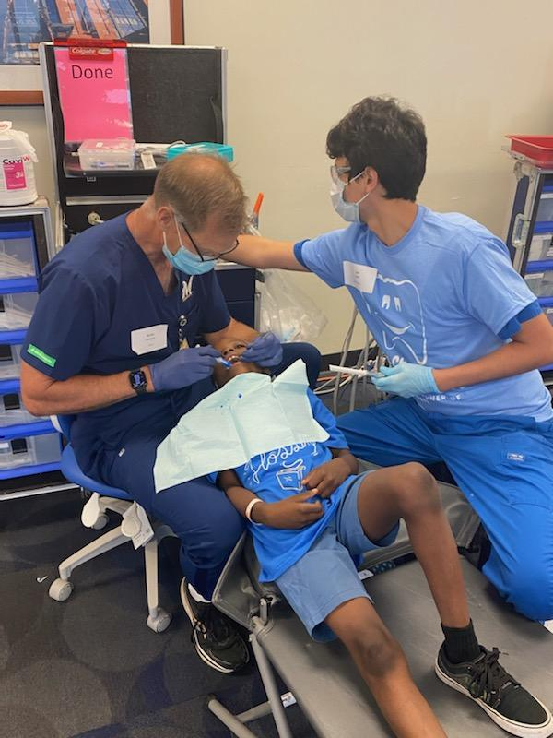
Education: $7,605

