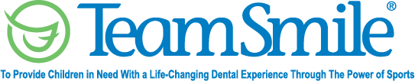
New Orleans Saints
August 23, 2022
Location of Dental Clinic: Caesars Superdome
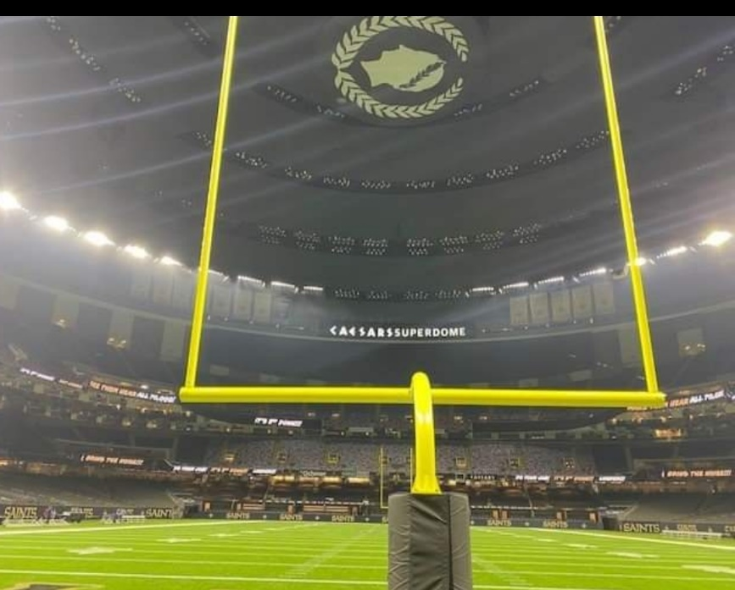
Community Academies
Crescent City Family Services
Women, Infants and Children program
116 Children Served
128 Children Educated

Total Preventative Care & Education Provided $48,193
Average Dental Care & Oral Health Education per patient visiting Program $365.80

Sponsored by:
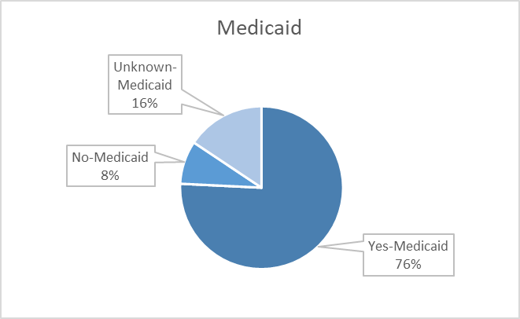
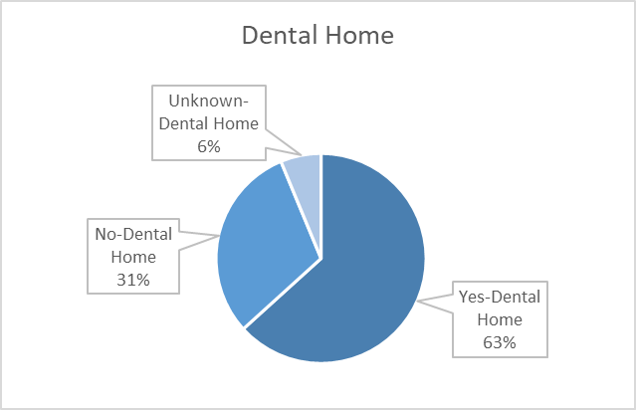
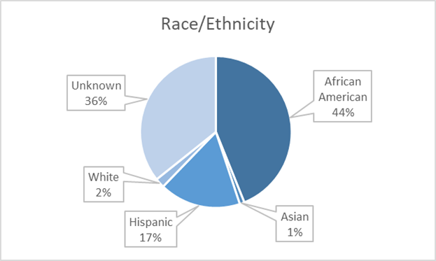
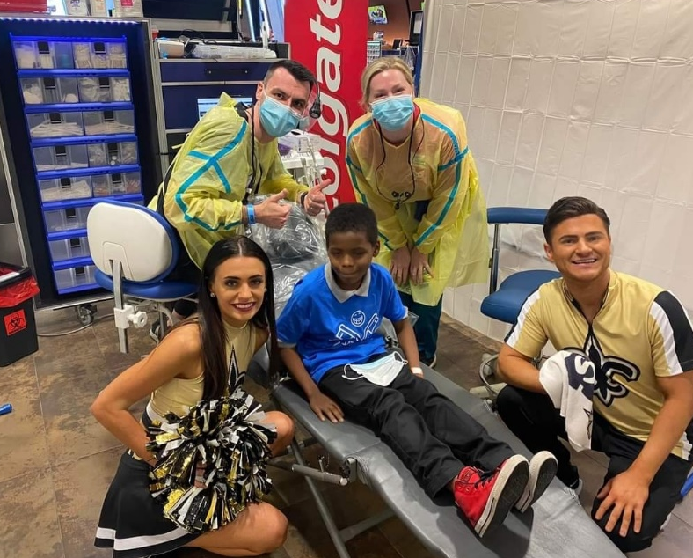
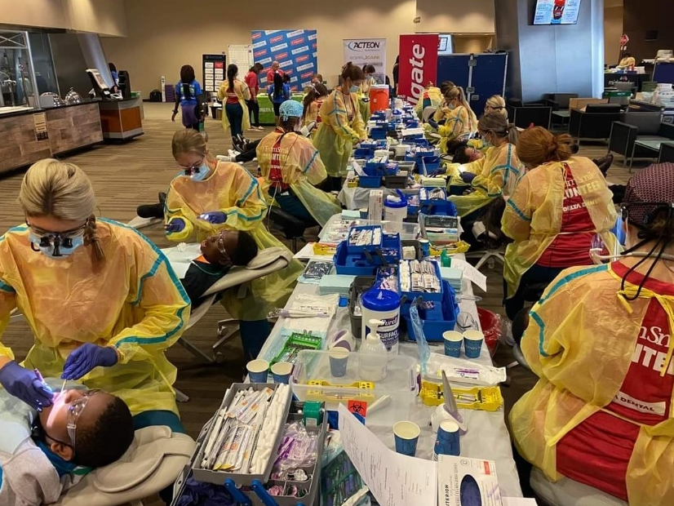
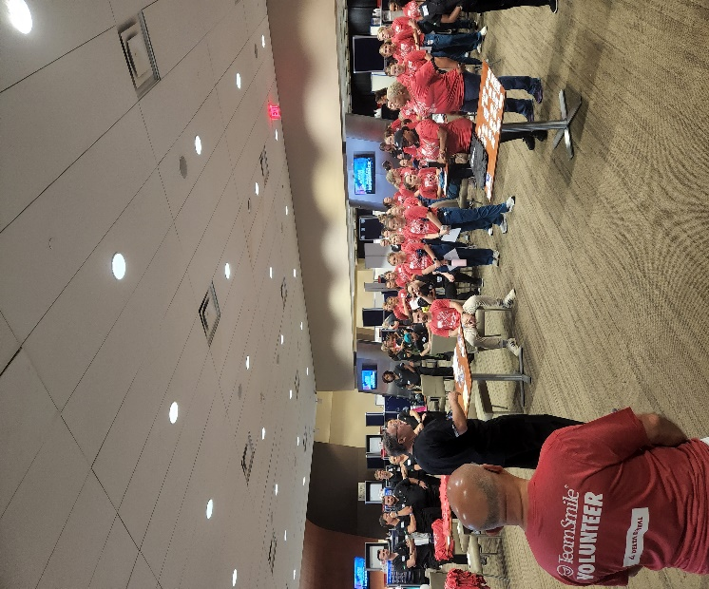
Volunteers
Thank you to our volunteers for your time and talents.
Dentists | 22 | 19
Hygienists | 22 | 21
Dental Assistants | 7 | 3
Dental School Students | 27 | 27
General Volunteers | 27 | 15
Total Volunteers | 105 | 85

Signed up Attended
81% Of the volunteers that signed up through our website attended the event.

Services

Screenings | 116
X-Rays | 104
Prophy Cleanings | 97
Fluoride Varnish | 81
Sealants | 145
Fillings | 22
Extractions | 12
Silver diamine fluoride | 9
Root Canals | 1
Oral Health Education | 128
Total Value: $48,193
Dental Services: $42,433
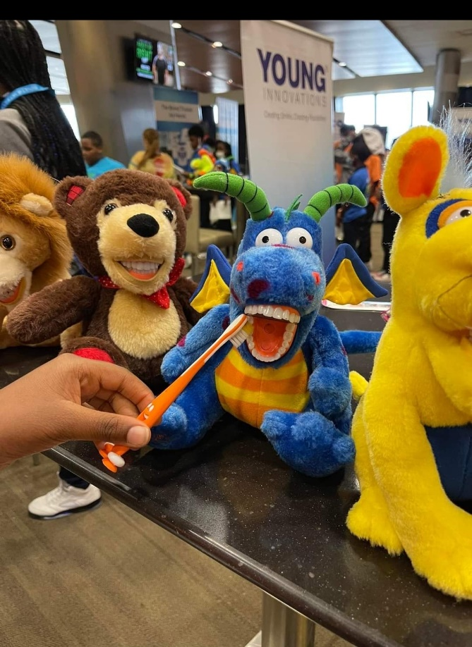
Education: $5,760

