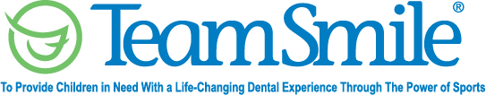
Pittsburgh Steelers
November 3, 2022
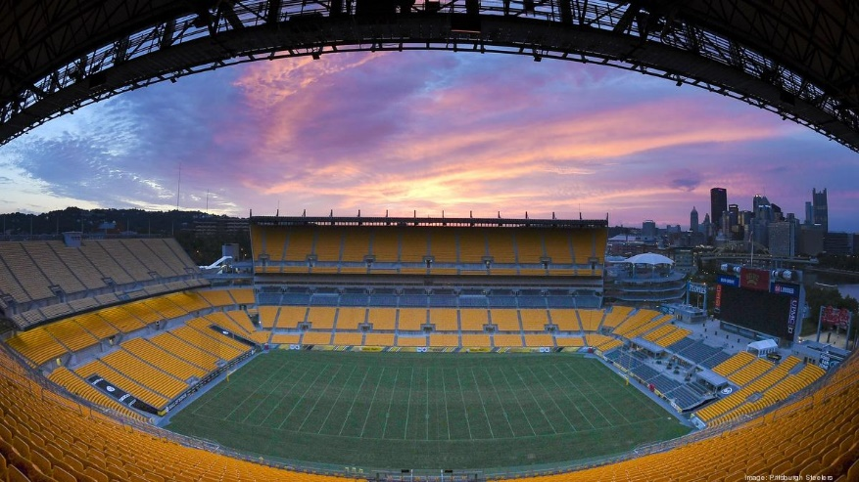
Location of Dental Clinic : Heinz Field
150 children served
162 children educated

Total Preventative Care & Education Provided $65,804
Average dental care provided for each patient in the dental clinic $390.09
Sponsored by:
United Concordia Dental, DentaQuest, Diehl Automotive and Davis, Davis & Associates
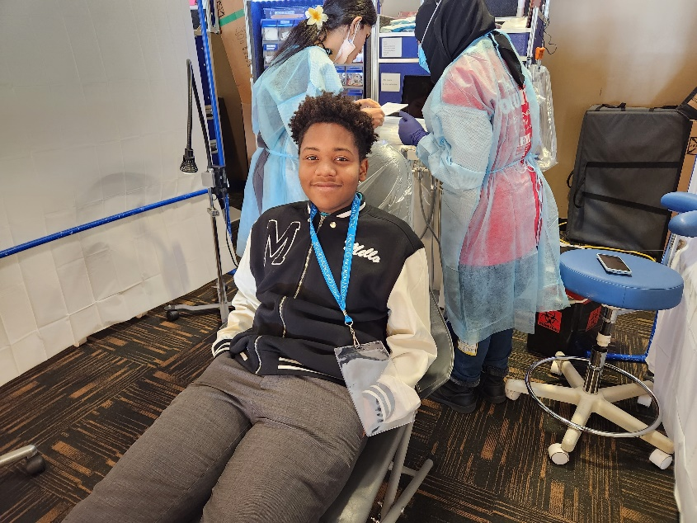
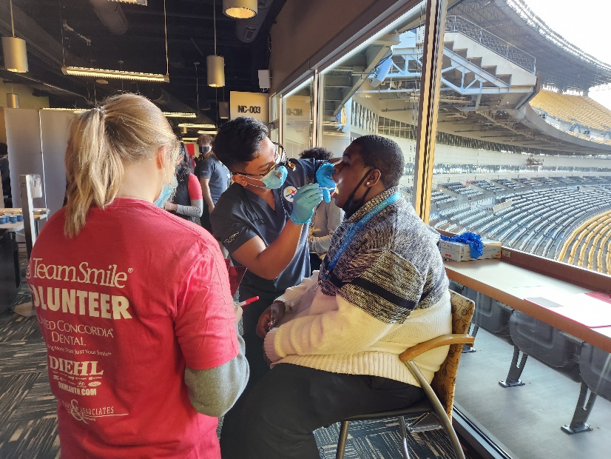
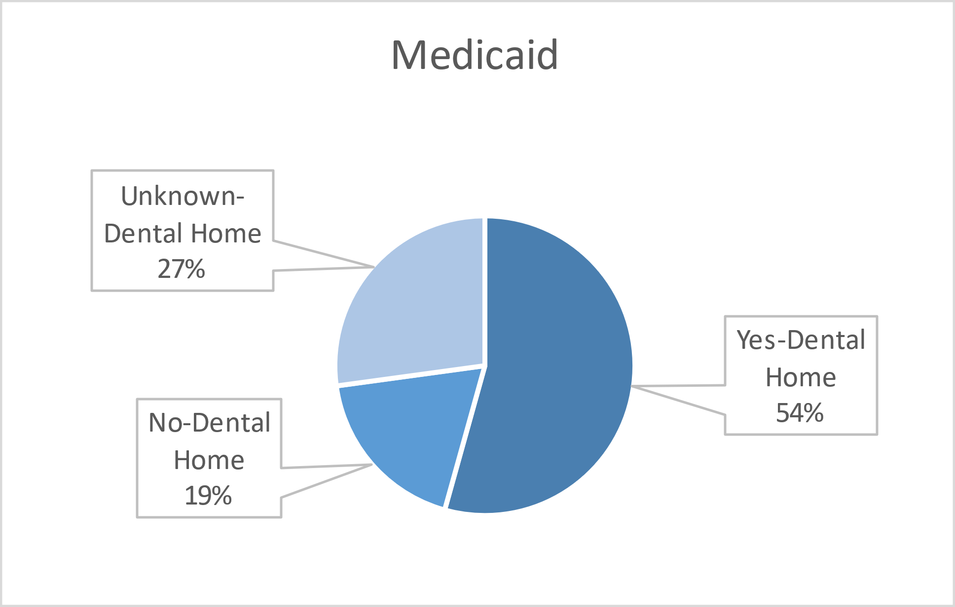
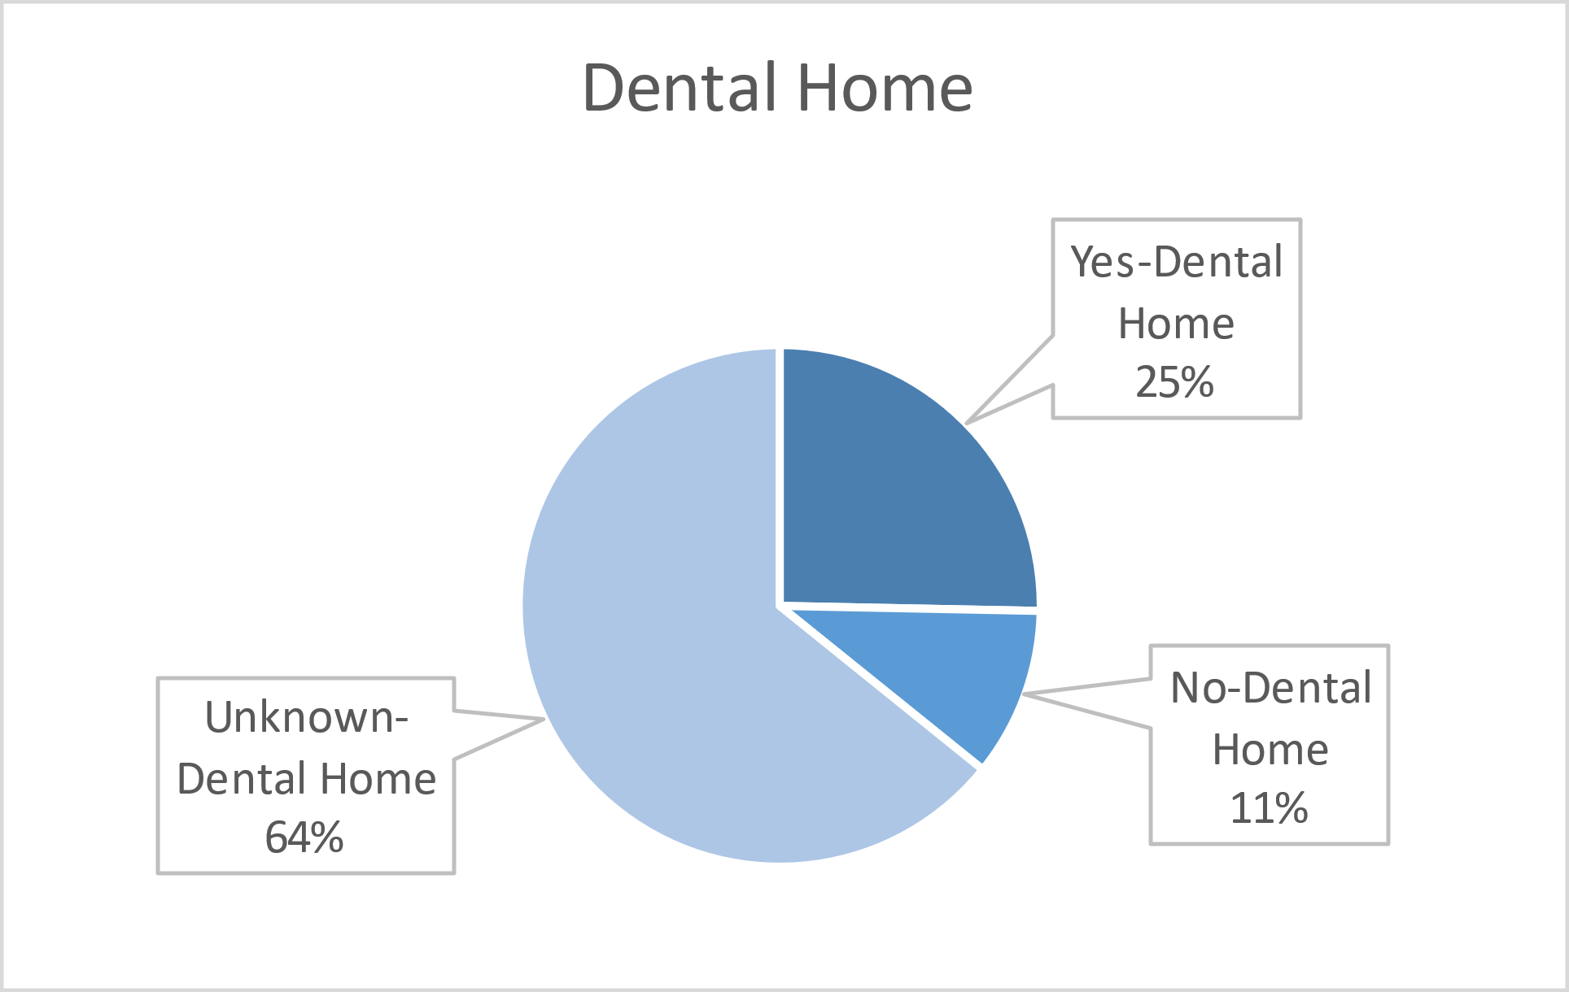
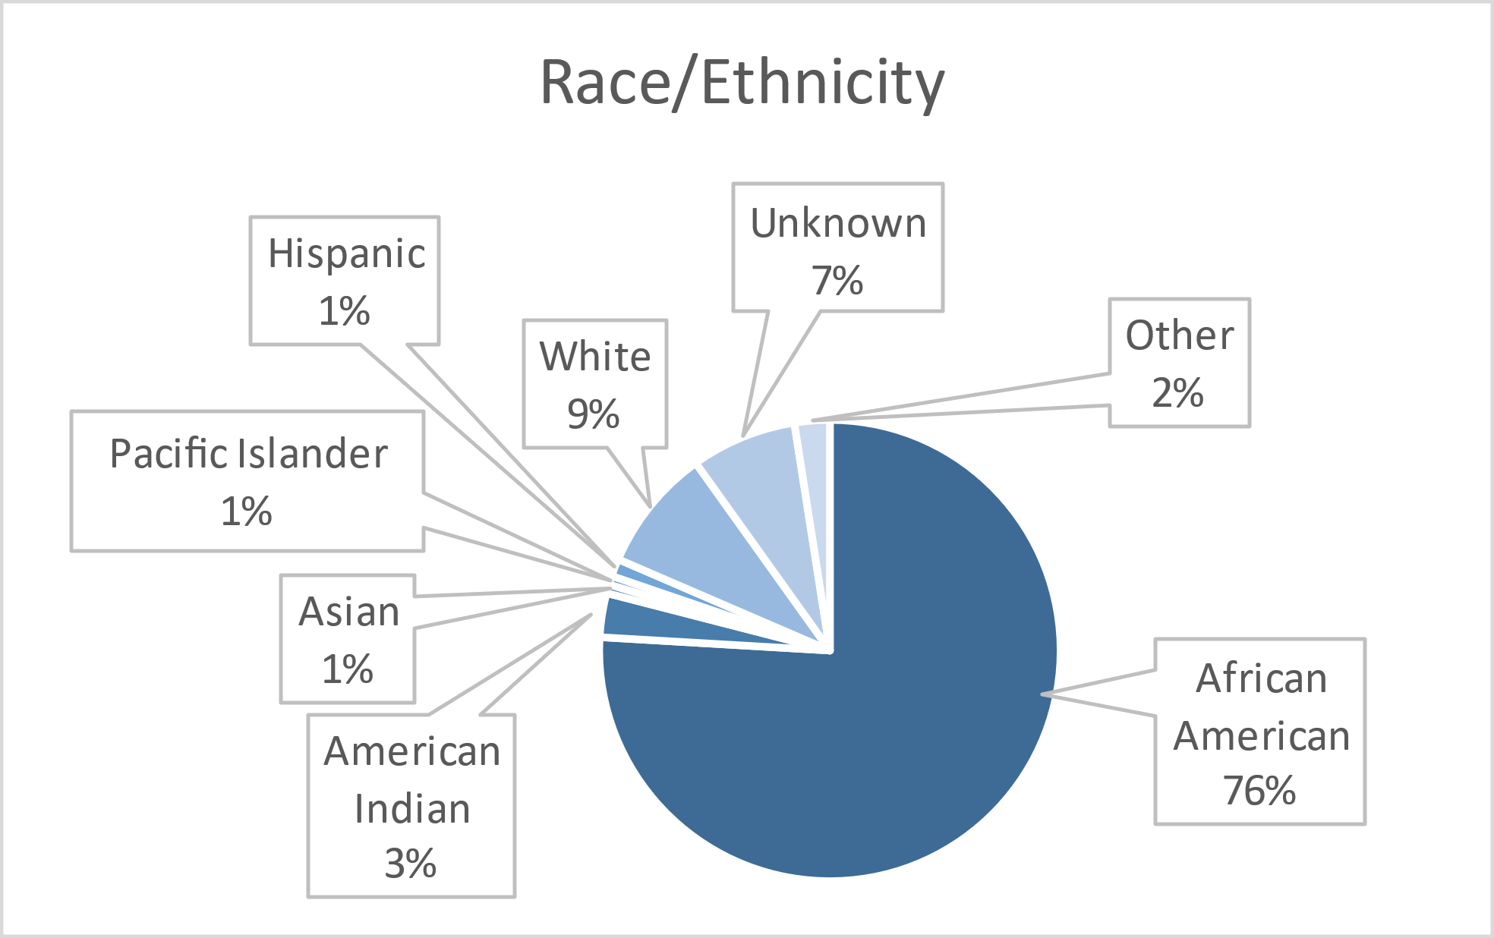

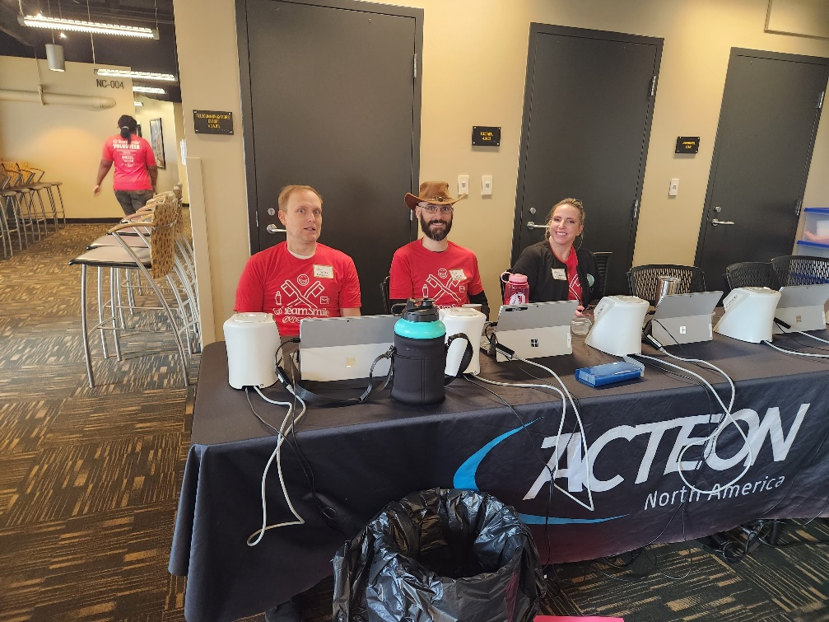Volunteers
Thank you to our volunteers for your time and talents.
Dentists | 20 | 16
Hygienists | 17 | 15
Dental Assistants | 20 | 14
Dental School Students | 2 | 2
General Volunteers | 68 | 52
Total Volunteers | 127 | 99
Signed up Attended
78% Of the volunteers that signed up through our website attended the event.

Screenings | 150
X-Rays | 154
Prophy Cleanings | 120
Varnish | 106
Sealants | 124
Fillings | 68
Extractions | 4
Root Canal | 1
Silver diamine fluoride | 7
Oral Health Education | 162
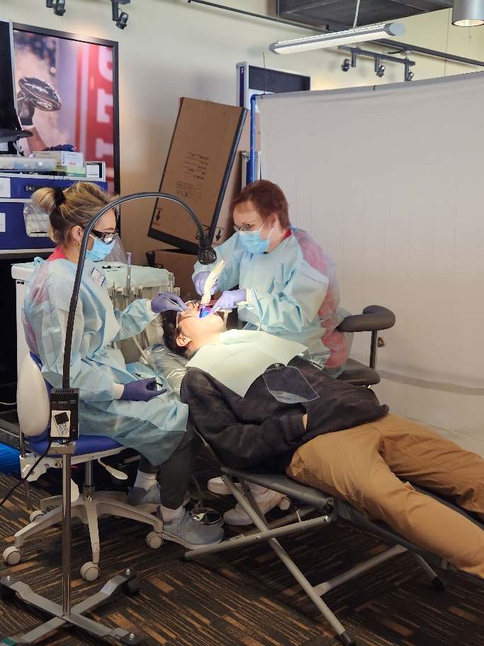
Services
Total Value: $65,804
Dental Services: $58,514
Education: $7,290

