
Prince William County
Phase II Back-to-school Program
August 11, 2023
Location of Dental Clinic: Unity Braxton Middle School
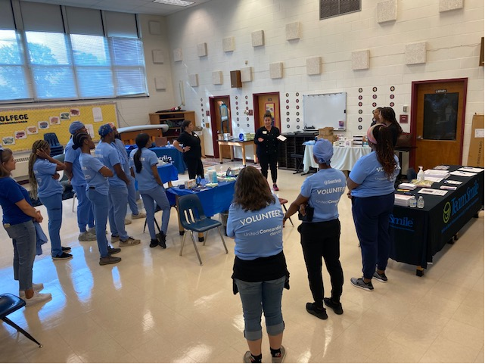

Back-to-school fair
47 Children Served
56 Children Educated

Total Preventative Care & Education Provided $13,777
Average Dental Care & Oral Health Education per patient visiting Program $246.01

Sponsored by:
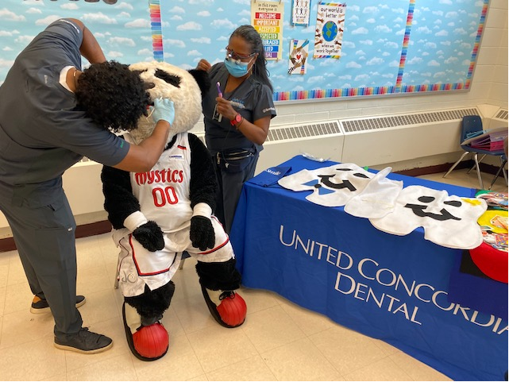
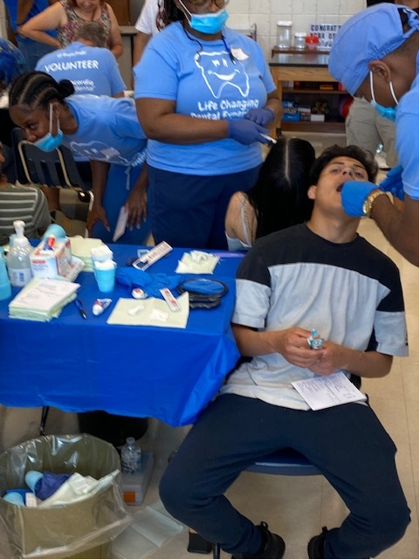
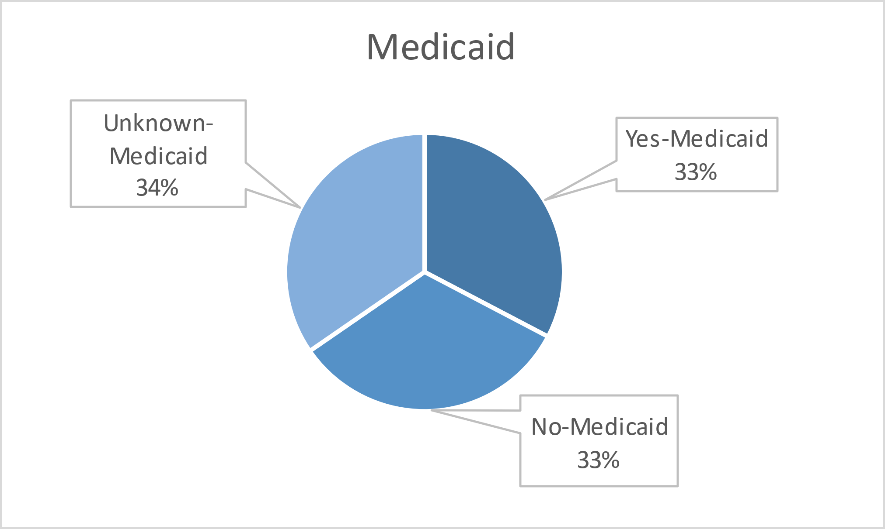
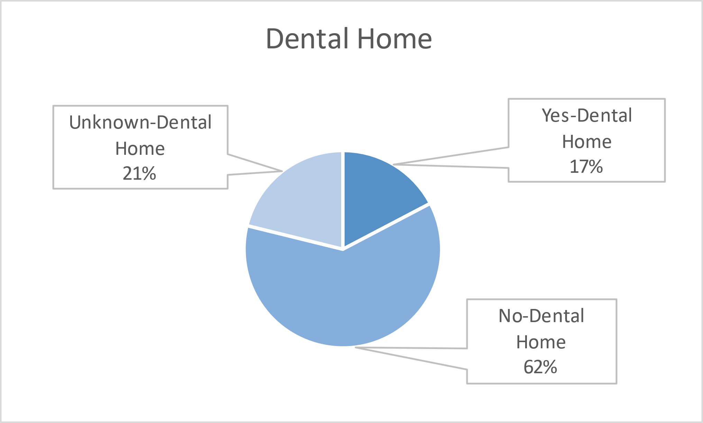
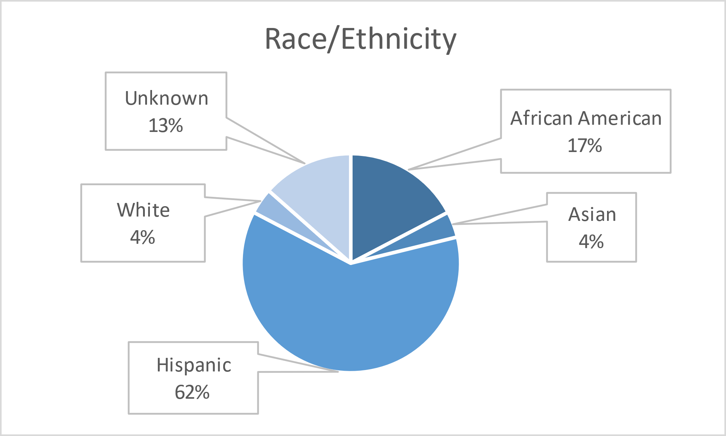
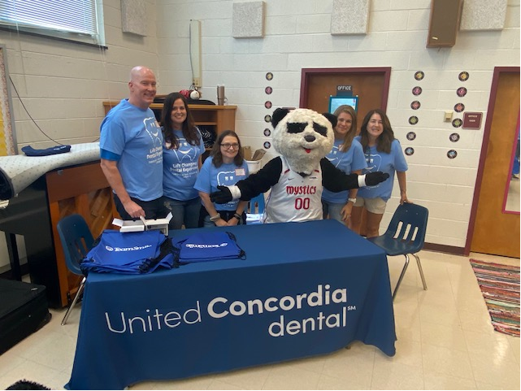
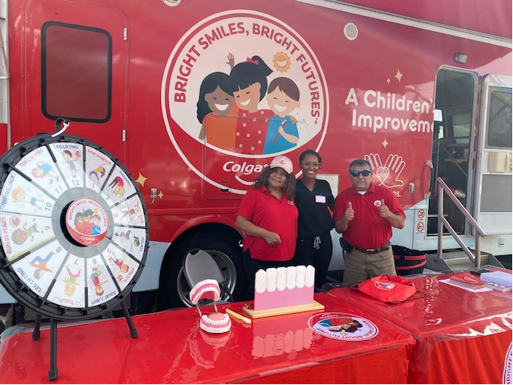
Volunteers
Thank you to our volunteers for your time and talents.
Dentists | 4 | 4
Hygienists | 6 | 4
Students | 4 | 4
General Volunteers | 23 | 17
Total Volunteers | 37 | 29

Signed up Attended
78% Of the volunteers that signed up through our website attended the event.

Services

Total Value: $13,777
Dental Services: $11,257
Screenings | 56
Cleanings | 47
Silver diamine fluoride | 22
Fluoride Varnish | 47
Education | 56
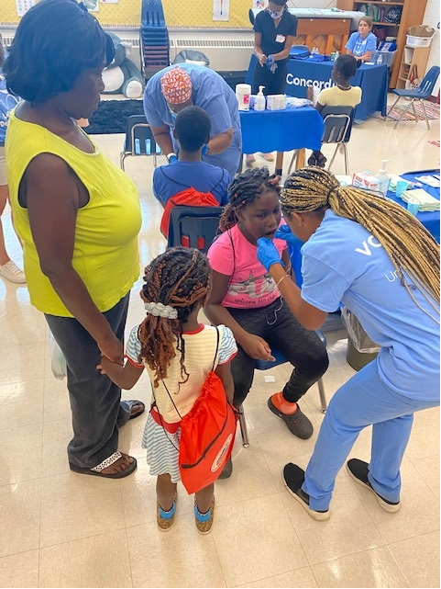
Education: $2,520

