Sacramento, CA
April 7, 2022
Location of Dental Clinic: Fairbanks Elementary


Fairbanks Elementary
Helping 166 Children

Total Preventative Care & Education Provided $32,900
Average Dental Care & Oral Health Education per patient visiting Program $370

Sponsored by : Shaq Thompson and Delta Dental
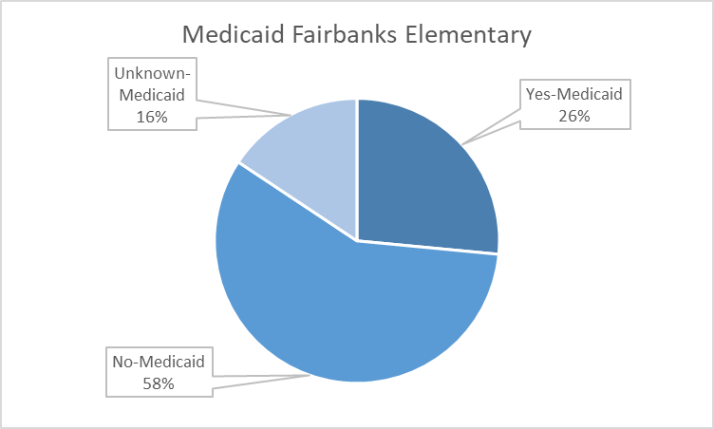
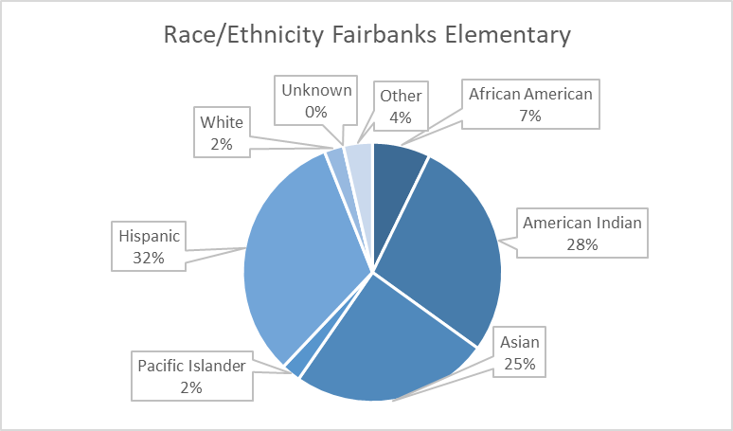
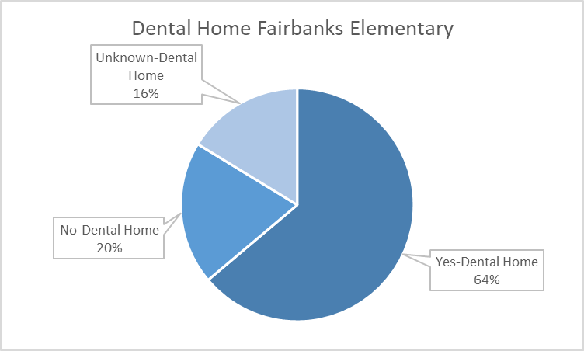


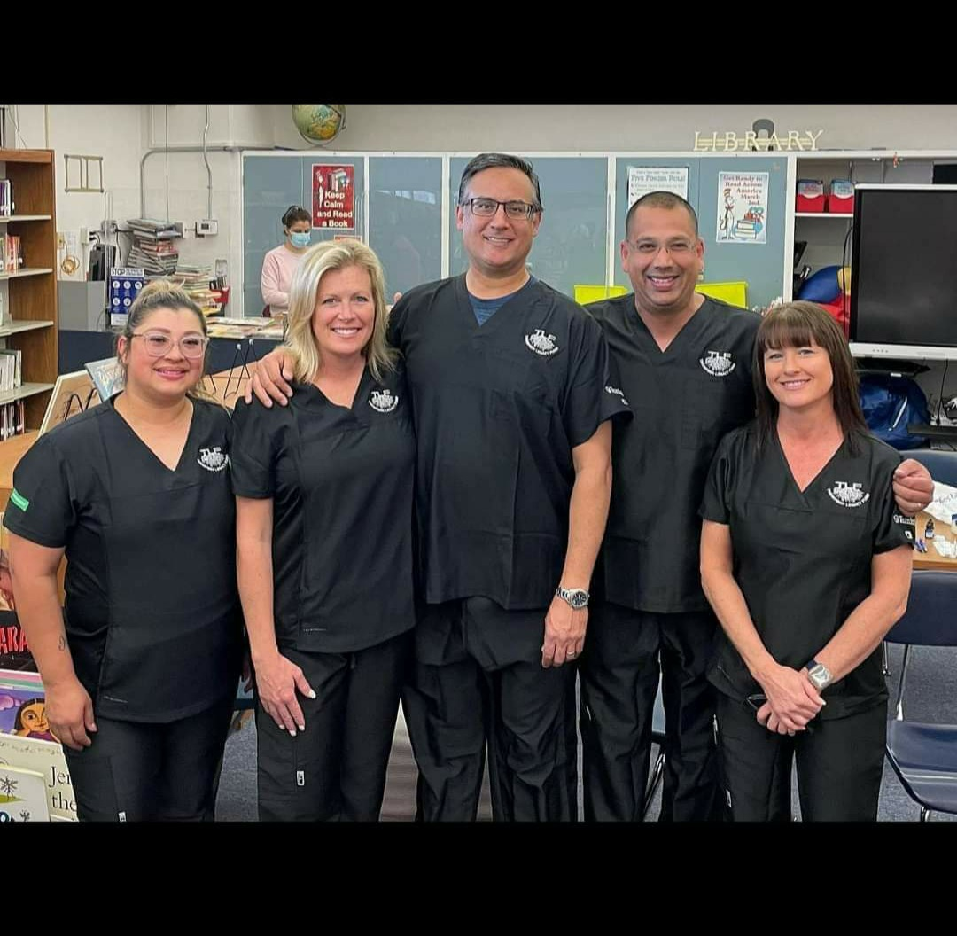
Volunteers
Thank you to our volunteers, for your time and talents.
Dentists | 1 | 1
Dental Assistants | 4 | 3
General Volunteers | 7 | 7
Total Volunteers | 12 | 11

Signed up Attended

99% Of the volunteers that signed up through our website attended the event.
Screenings | 166
Fluoride Varnish | 166
Silver Diamine Fluoride | 104
Oral Health Education | 166
Services

Total Value: $32,900

Dental Services: $25,430

Education: $7,470

