
St. Louis Cardinals
Phase II Back-to-school Program
August 12, 2023
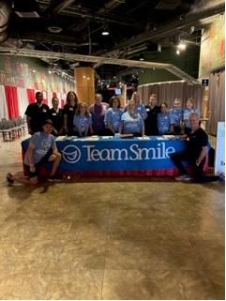
Location of Dental Clinic: Busch Stadium

Back-to-school fair
83 Children Served
97 Children Educated
Total Preventative Care & Education Provided $23,813
Average Dental Care & Oral Health Education per patient visiting Program $245.49


Sponsored by:
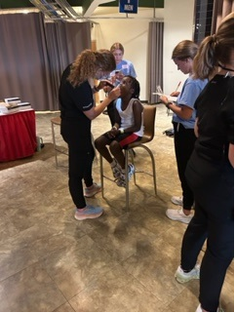
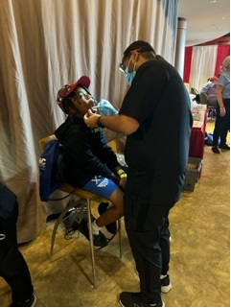
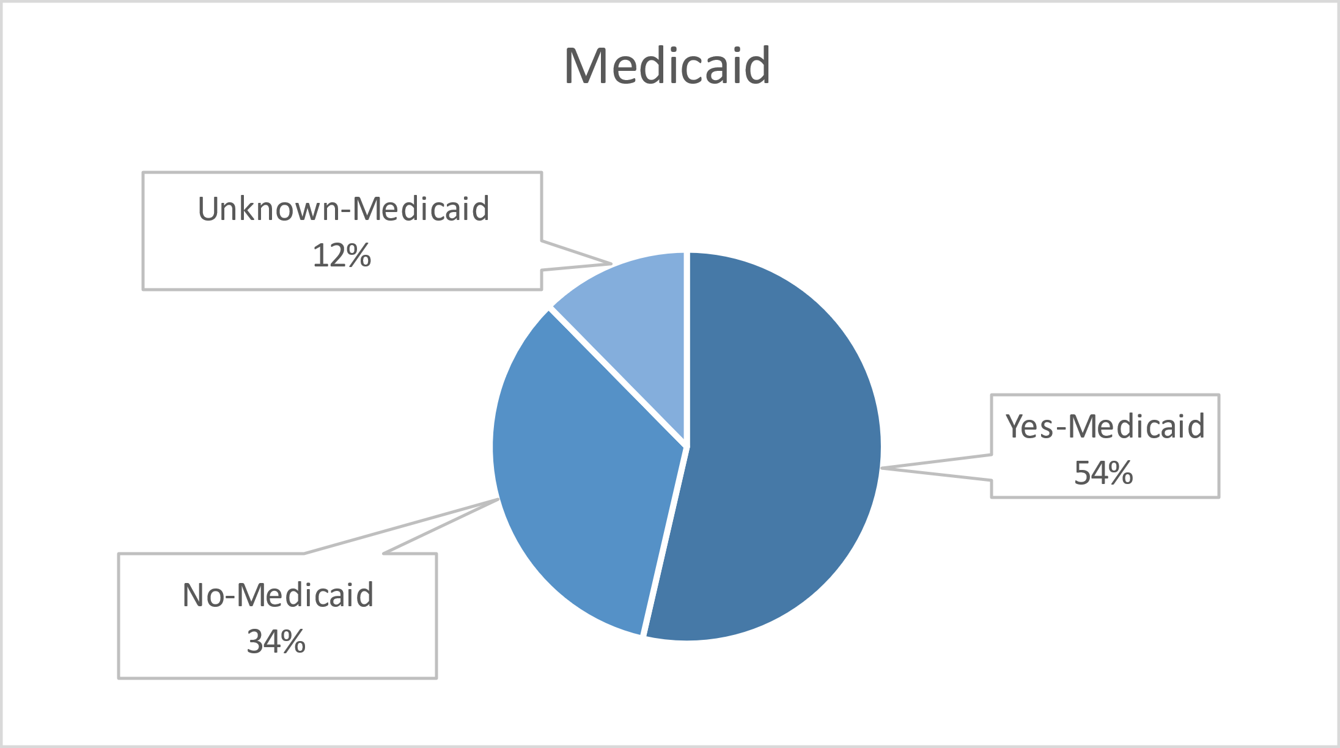
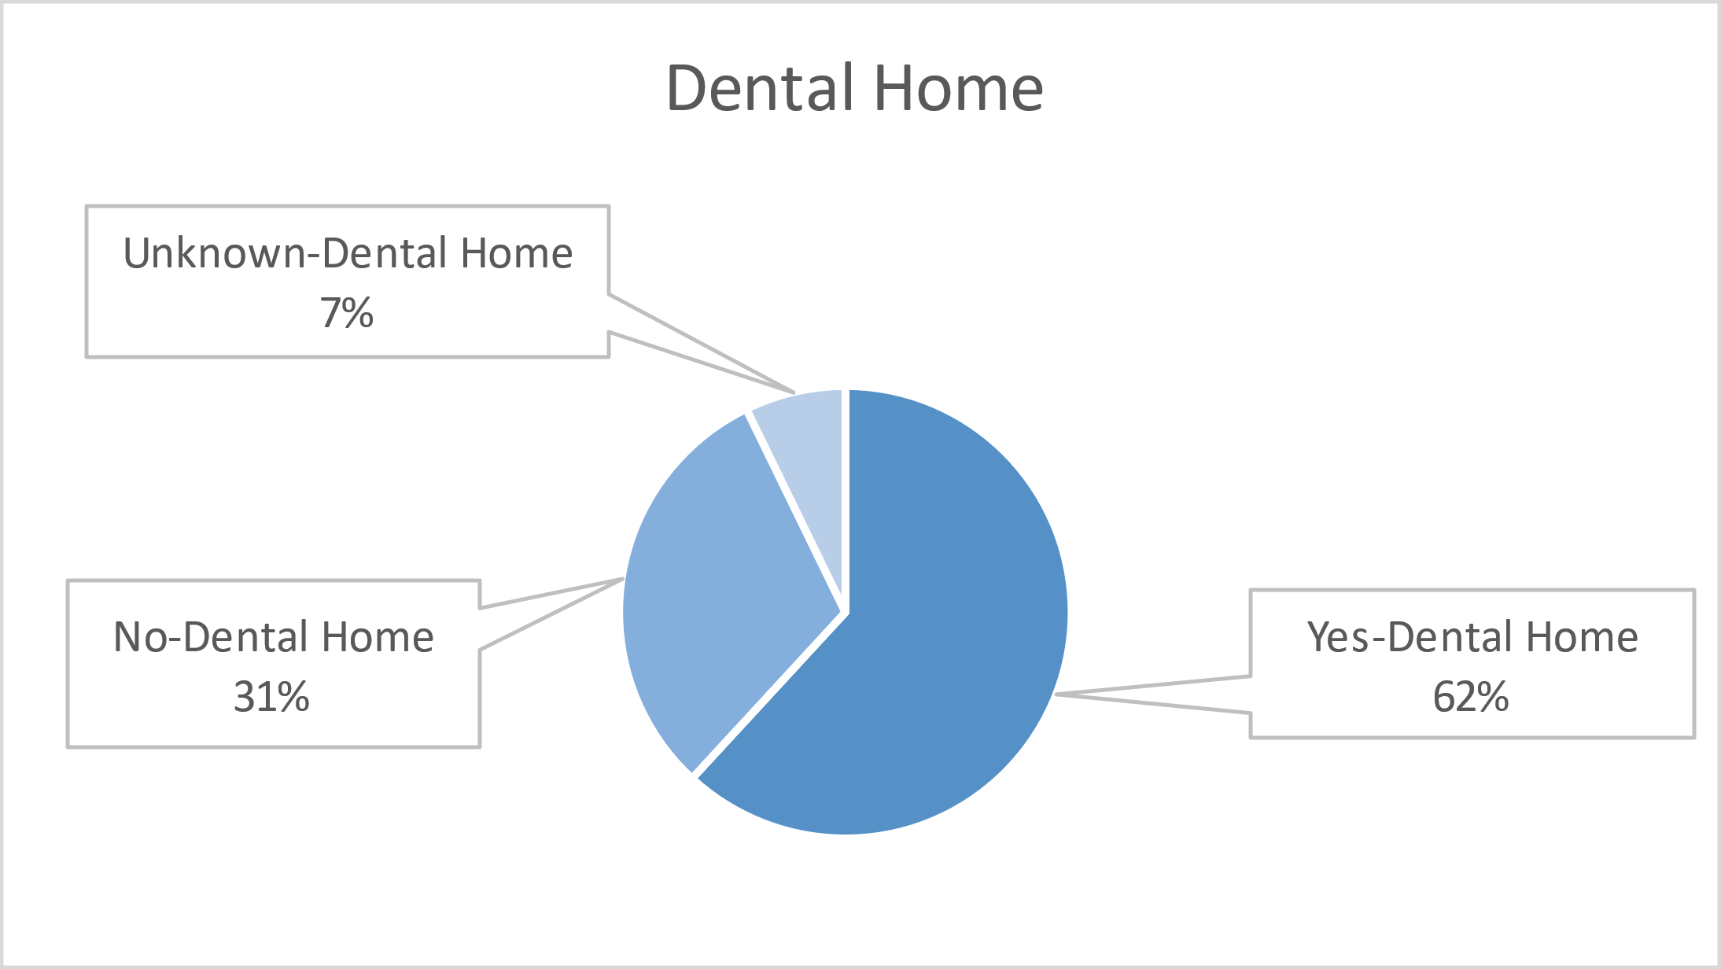
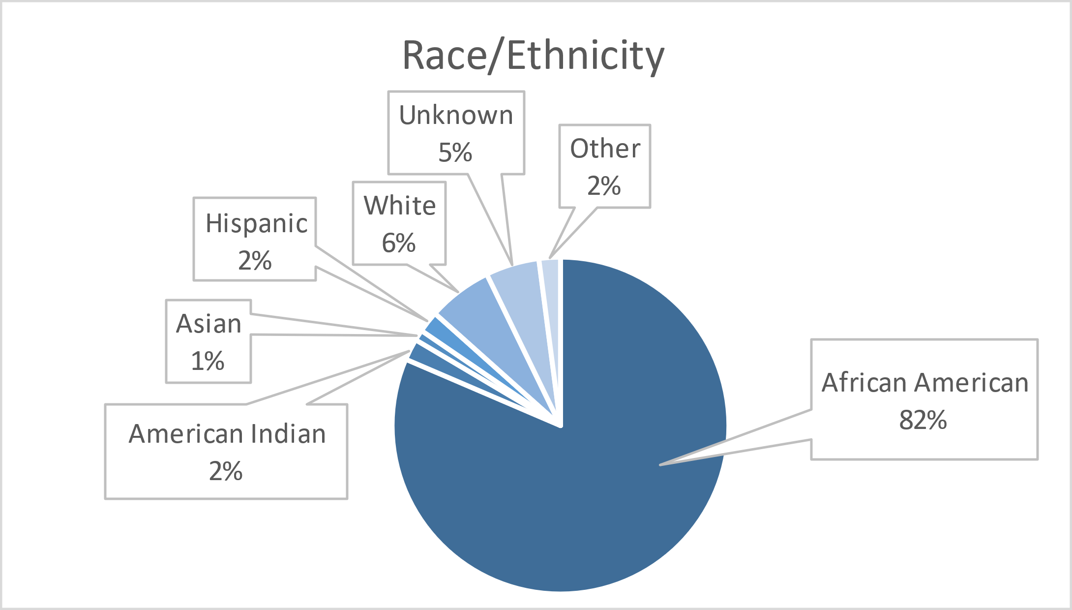
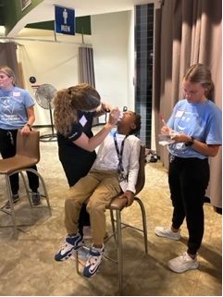
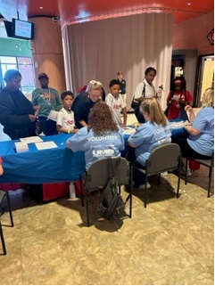
Volunteers
Thank you to our volunteers for your time and talents.
Dentists | 5 | 5
Hygienists | 4 | 4
Dental Volunteers | 5 | 5
General Volunteers | 12 | 12
Total Volunteers | 26 | 25

Signed up Attended
100% Of the volunteers that signed up through our website attended the event.

Service
Total Value: $23,813
Dental Services: $19,448
Screenings | 97
Cleanings | 83
Silver diamine fluoride | 32
Fluoride Varnish | 83
Education | 97
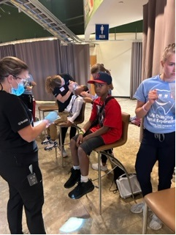
Education: $4,365

