
Minnesota Vikings
October 11, 2022
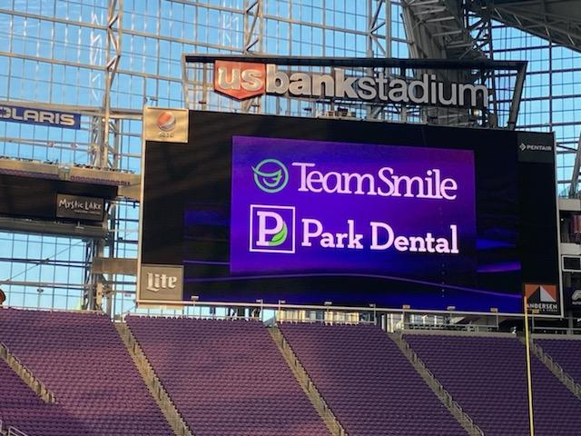
Location of Dental Clinic : US Bank Stadium
83 children served
92 children educated

Total Preventative Care & Education Provided $35,890
Average dental care provided for each patient in the dental clinic $382.53


Sponsored by:

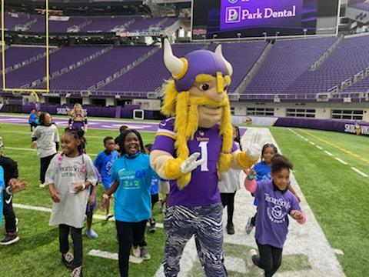
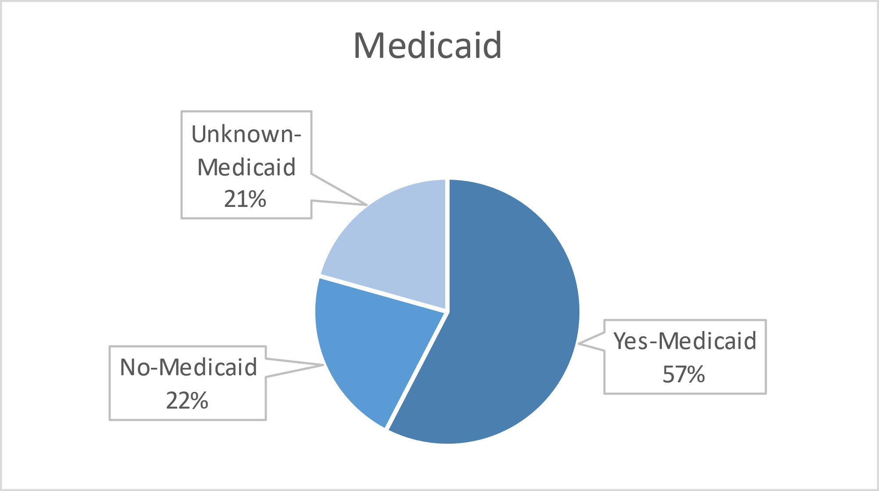
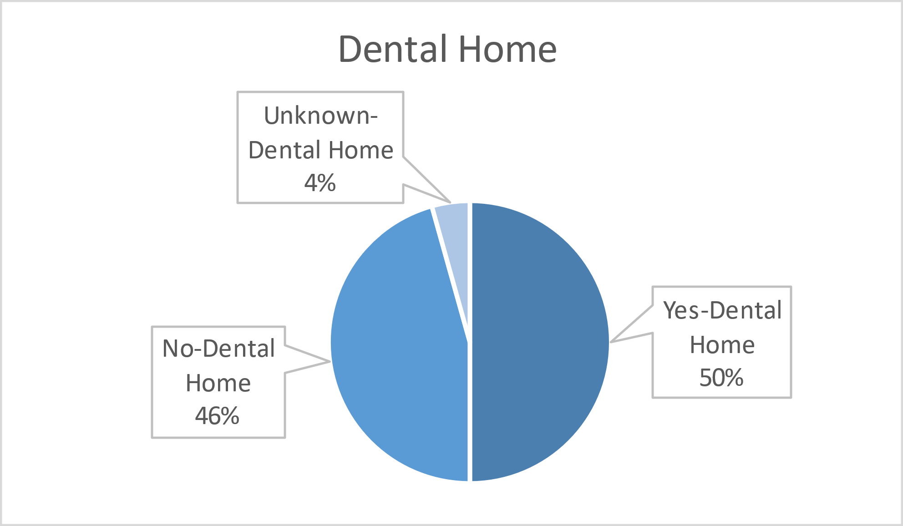
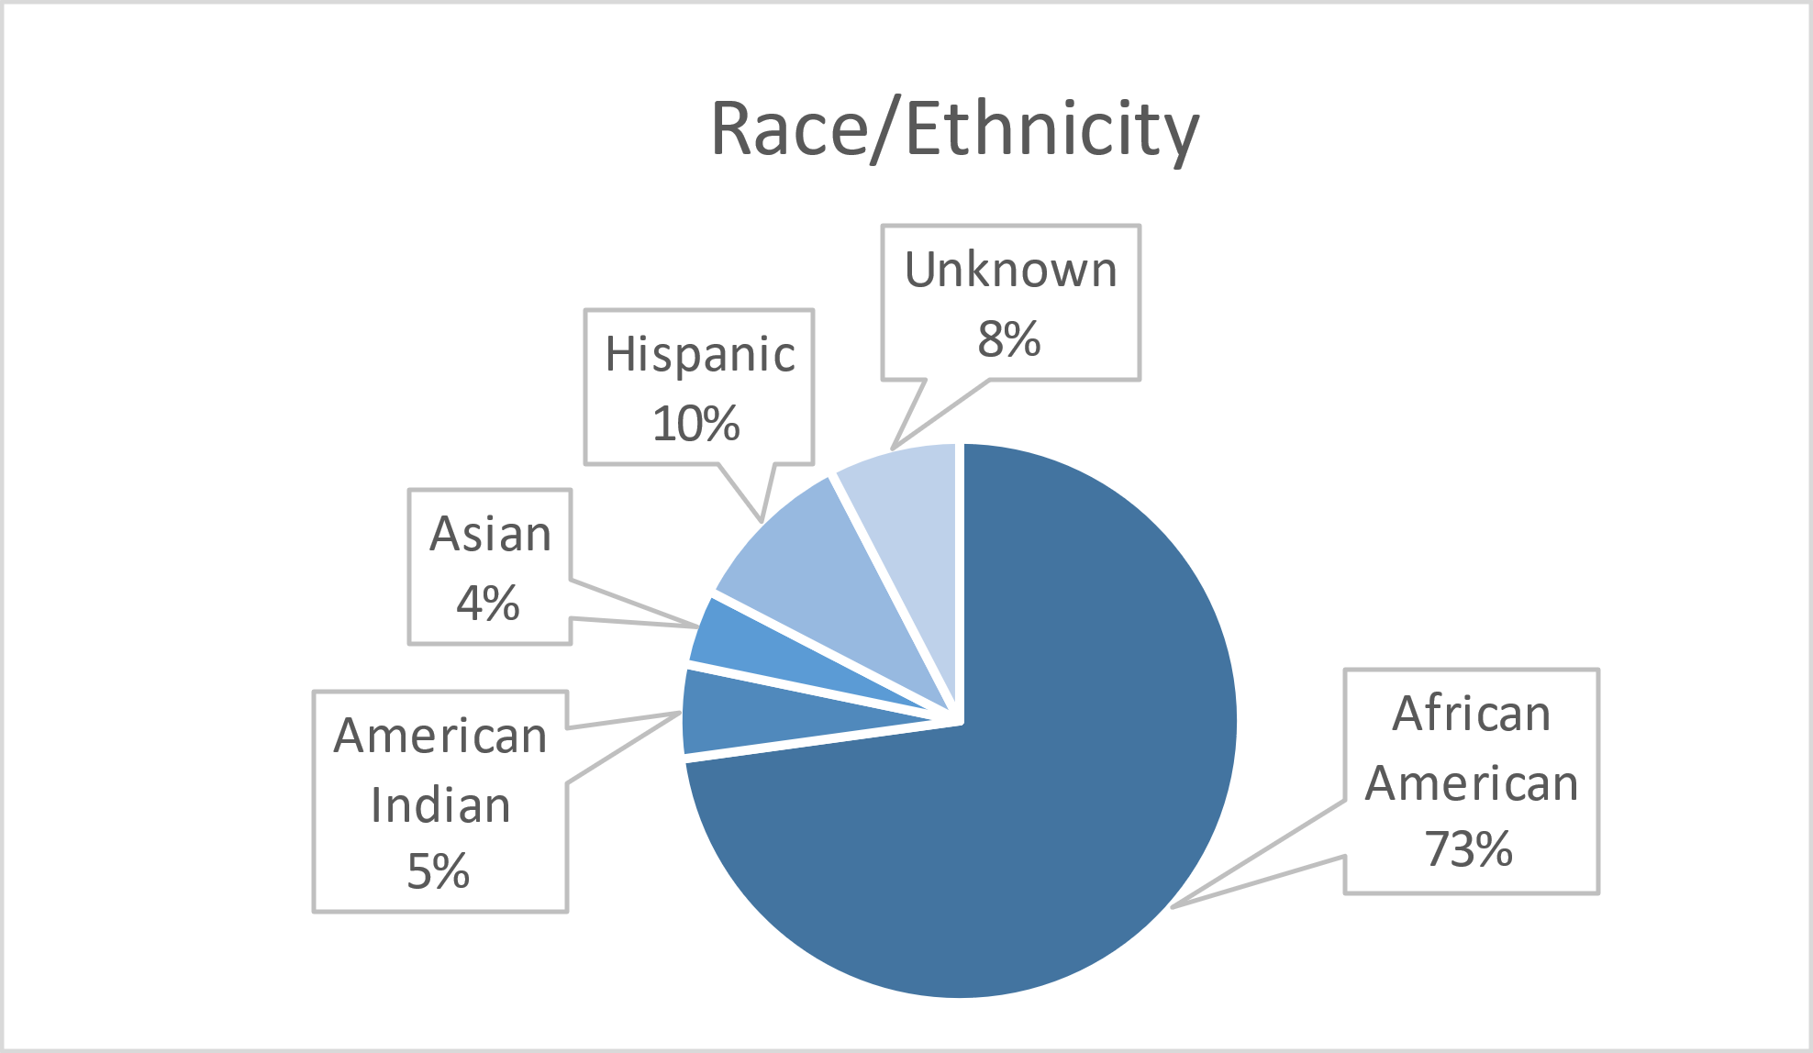

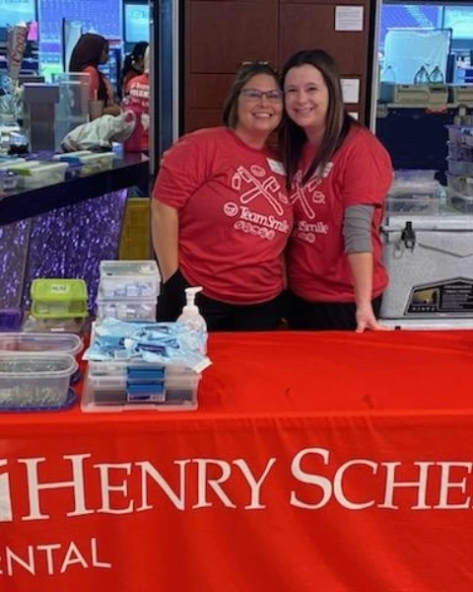
Volunteers
Thank you to our volunteers for your time and talents.
Dentists | 20 | 19
Hygienists | 14 | 12
Dental Assistants | 23 | 21
Dental School Students | 24 | 21
General Volunteers | 75 | 54
Total Volunteers | 156 | 127
Signed up Attended
81% Of the volunteers that signed up through our website attended the event.

Screenings | 83
X-Rays | 60
Prophy Cleanings | 73
Fluoride Varnish | 63
Sealants | 101
Fillings | 21
Extractions | 4
Silver diamine fluoride | 35
Oral Health Education | 92
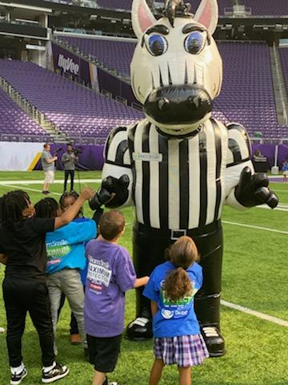
Services
Total Value: $35,890
Dental Services: $31,750
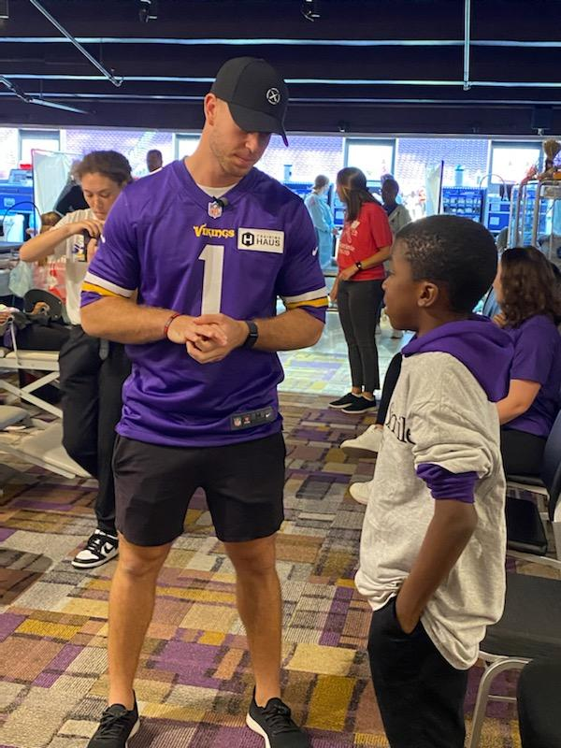
Education: $4,140

