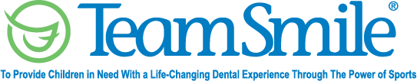
TeamSmile in D.C.
July 29, 2022
Location of Dental Clinic: Nationals Youth Baseball Academy &
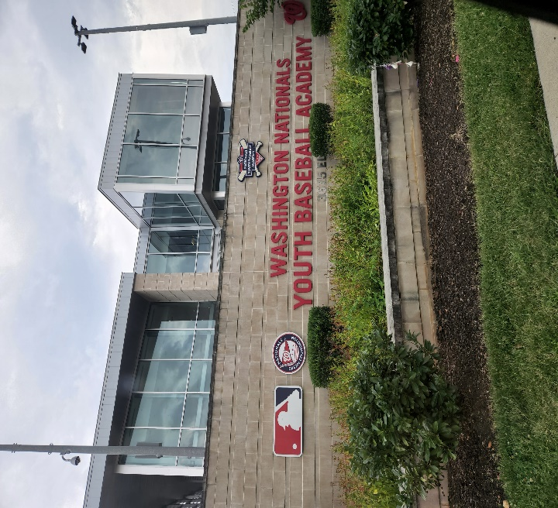
Hylton Club and Boys and Girls Club of Greater Washington
Youth Baseball Scholars and Boys and Girls members
144 Children Attended
223 Children Educated with the Colgate bus presented at the Youth Baseball Academy

Total Preventative Care & Education Provided $36,510
Average Dental Care per patient visiting Program $253.54


Sponsored by:
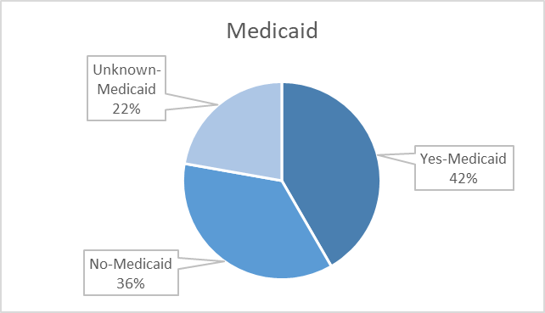
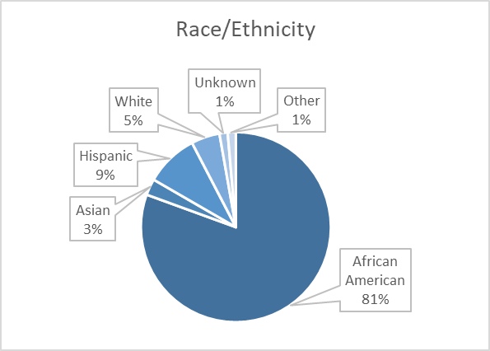
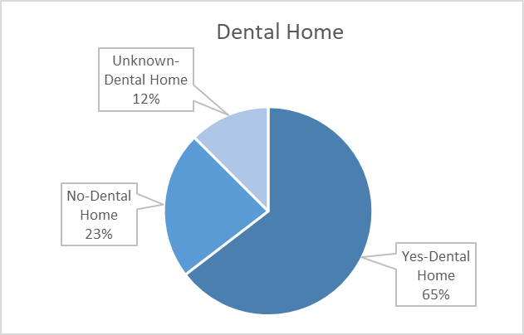
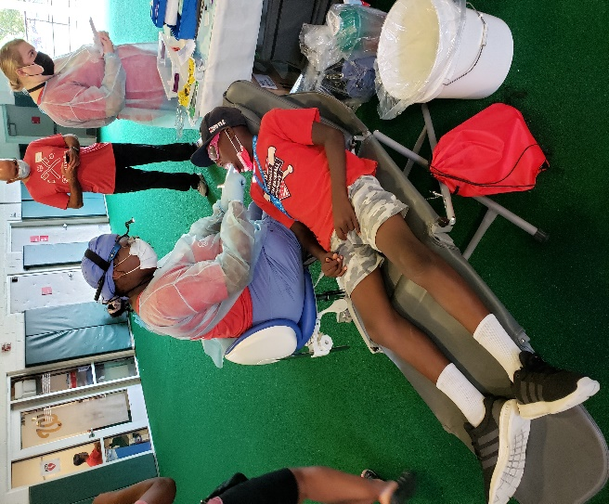
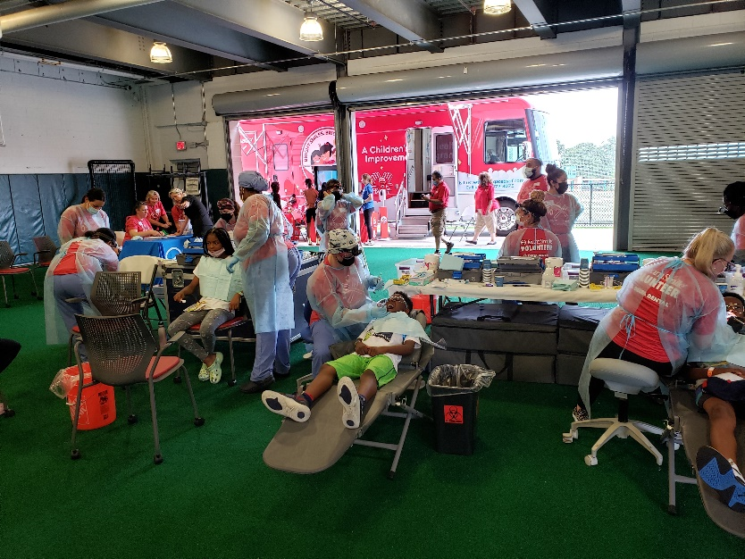
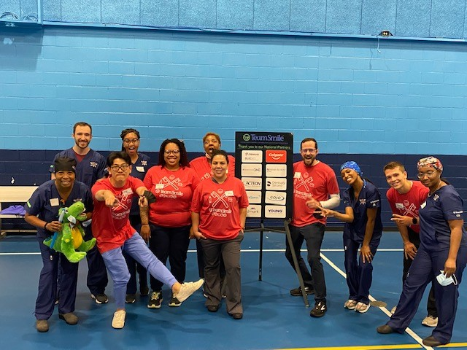
Volunteers
Thank you to our volunteers for your time and talents.
Dentists | 15 | 12
Hygienists | 4 | 4
Dental Assistants | 8 | 3
Dental School Students | 17 | 16
General Volunteers | 43 | 26
Total Volunteers | 87 | 61

Signed up Attended
70% Of the volunteers that signed up through our website attended the event.

Screenings | 97
X-Rays | 59
Prophy Cleanings | 93
Fluoride Varnish | 90
Fillings | 5
Extractions | 5
Silver Diamine Fluoride | 23
Crowns | 2
Oral Health Education | 176

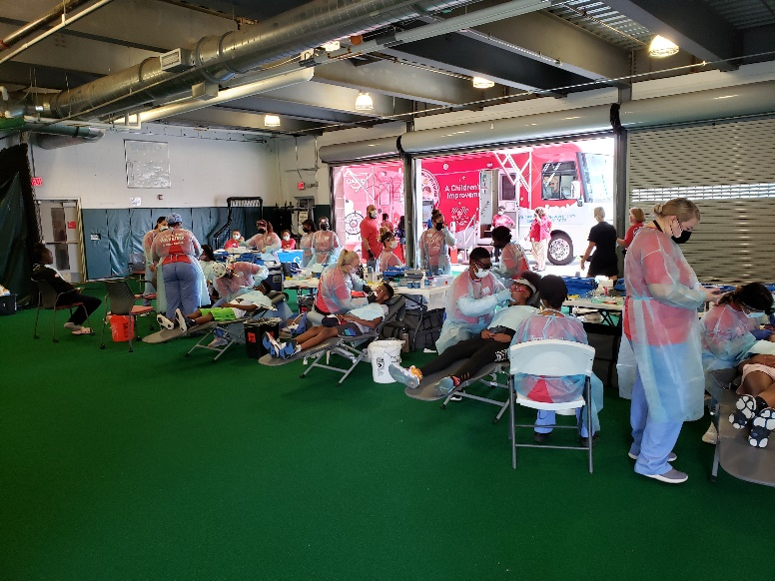
Nationals Youth Baseball Academy

Screenings | 47
Prophy Cleanings | 47
Fluoride Varnish | 47
Silver Diamine Fluoride | 13
Education | 47
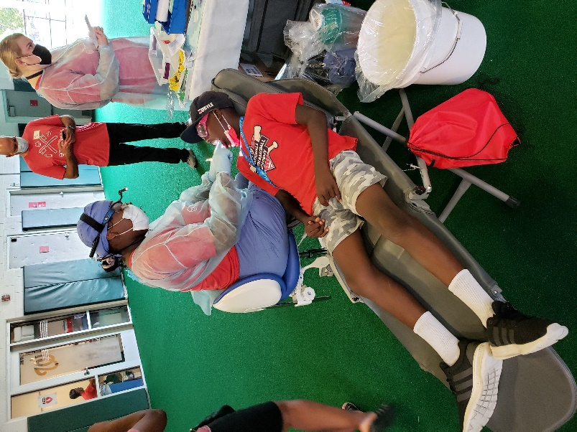
Boys and Girls Club of America

